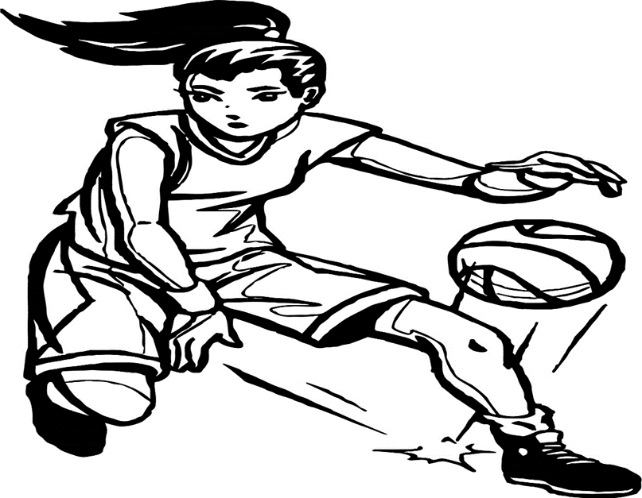

**2021 Deerlake Girls Basketball**

**Tryout Form**

STUDENT’S NAME __________________________________________________

**(Please Print First and Last Name)**

**Try-out Dates:**

**Monday, October 4th 7:15am-8:45am**

**Tuesday, October 5th 7:15am-8:45am**

**Wednesday, October 6th 7:15am-8:45am**

All students who wish to try out for the DMS Girls Basketball Team must be able to fulfill the following criteria:

* Have proof of a current physical from a doctor (A physical is valid for 12 months from the date it was obtained) on file in the front office.
* Covid form completed and returned to Coach Watkins by **Friday, October 1, 2021**
* Permission tryout form to Coach Watkins by **Friday, October 1, 2021**
* Able to attend Try-outs/Practices/Games
  + Tryouts (October 4th-6th 7:15am-8:45am)
  + Practice Prior to Season Kick off
    - M,T,W,TH,F 7:15am-8:45am
  + In Season practice following first game
    - M,W,F with Morning/Evening Practice
  + Games
    - T, TH Games @ 6:00pm

**-Please See Next Page-**

Student Signature _____________________________________________

Grade ________________________

I give my child permission to try out for the 2020-2021 DMS Girls Basketball Team:

Parent Name: ________________________________________________

Parent Phone: ________________________________________________

Parent Signature _____________________________________________

What can you offer to the DMS Girls Basketball Program?

__________________________________________________________________________________________________________________________________________________________

Please tell us about your basketball experience (participate on a team outside of school, played basketball last year, etc):

_____________________________________________________________________________

_____________________________________________________________________________

Are you *currently* participating in another sport or club? (basketball, soccer, softball, etc.)

_____________________________________________________________________________

Do you have any conflicts with Morning (7:15-8:45am), Afternoon (4:00-5:30pm) practices, and games (T&TH 6:00pm) that wouldn’t allow you to participate?

__________________________________________________________________________________________________________________________________________________________

**\* This signed form must be returned to Coach Watkins by Friday, October 1, 2021\***

**(You must have a current physical and activity participation form on file with the front office)**

If you have any questions, please feel free to contact Coach Watkins by email at watkinsl@leonschools.net or by phone at 850-922-6545. Looking forward to seeing everyone at tryouts October 4th-6th 7:15am-8:45am.