 Tell if each equation is true or false. (Solve each… move the decimal )

 | True | False
36.4 ÷ 10 = 3.64
528.3 ÷ 100 = 52.83
45,192.6 ÷ 100 = 451.926
 A gardener has 3.69 pounds of plant food. If he divides it into equal portions for
3 tomato plants, which quick picture shows how much plant food he has for
each plant? (hint- think… what shows 3.69 divided into 3 groups?)
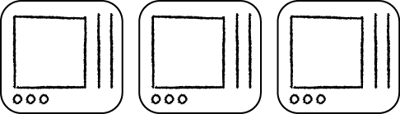
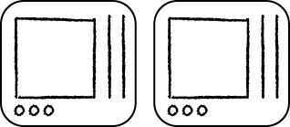
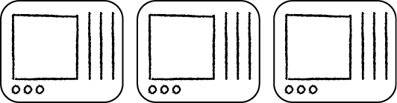
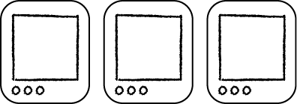

 Ellen drove 357.3 miles. If her car gets 21 miles on each gallon of gas, ABOUT how many gallons will she use to make the trip?
1.8 gallons
18 gallons
180 gallons

 Mia has a spool of ribbon that is
30.5 yards long. She will cut the
ribbon into 5 equal pieces to make bows. What is the length of each
piece of ribbon?
______ yards
 A mountain climber eats 43.8 ounces of trail mix during an 8-day climb. Which estimate is the BEST for the ounces of trail mix the mountain climber eats each day?
10 ounces
5 ounces
3 ounces
2 ounces

 Latisha hiked along a trail that was 23.8 miles long. She hiked 4 miles every hour. How long did it take Latisha to finish hiking the trail? (remember… no remainders… add 0s if you need to.)
5 hours
4.95 hours
5.95 hours
40 hours

 Grant is making small bags of dried fruit from a large bag of dried fruit that weighs
5.46 pounds. If he puts the same amount of dried fruit in each of 6 bags, how much
will each bag weigh?
______ pound(s)

 Match the answer with the expression equation. (Hint, solve and connect with a line. Think about moving the decimal)
  48.6 ÷ 10 = |  | 0.486
48.6 ÷ 1 = |  | 4.86
48.6 ÷ 100 = |  | 48.6
48.6 ÷ 1000 = |  | 0.0486

 Reshawn is buying 3 books in a set for $24.81. He will save $6.69 by buying the whole set instead of buying the 3 books separately. If each book costs the same amount, how much does each of the 3 books cost when purchased individually?
$ ______ each
(Hint- multi-step problem)

