Name: Rayana Hughes Initals: RSH

Birthday: *12/04*

Preferred t-shirt size? Adult Medium

What is your favorite color? Pastel Yellow, Cyan, Pastel Pink

What is your favorite flower/plant? Tulips

Where are your favorite places to shop? Target, Amazon, Madewell

What are your favorite restaurants? Chick-Fil-A What do you collect ? Candles, Destination fridge magnets What is your favorite cold drink?

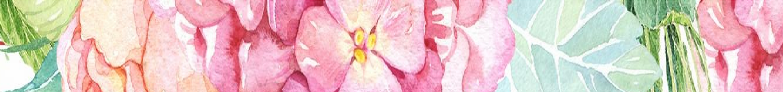‘Bai’ flavored water

What is your favorite hot drink?

Matcha latte with almond milk

What is your favorite sweet treat?

A Soft Bakery Cookie

What is your favorite salty treat?

Trader Joe’s rolled chips

What is your favorite fruit?

Green Grapes or Pineapple

Do you have any food allergies?

I do not :)

Interests: Reading, Writing, Nature UMOJA House:

Symponia

Wish list for your classroom?

* Clorox wipes and Microban (both fresh scent)
* Expo markers
* Whiteboard eraser spray
* Class games/tinker toys
* Books