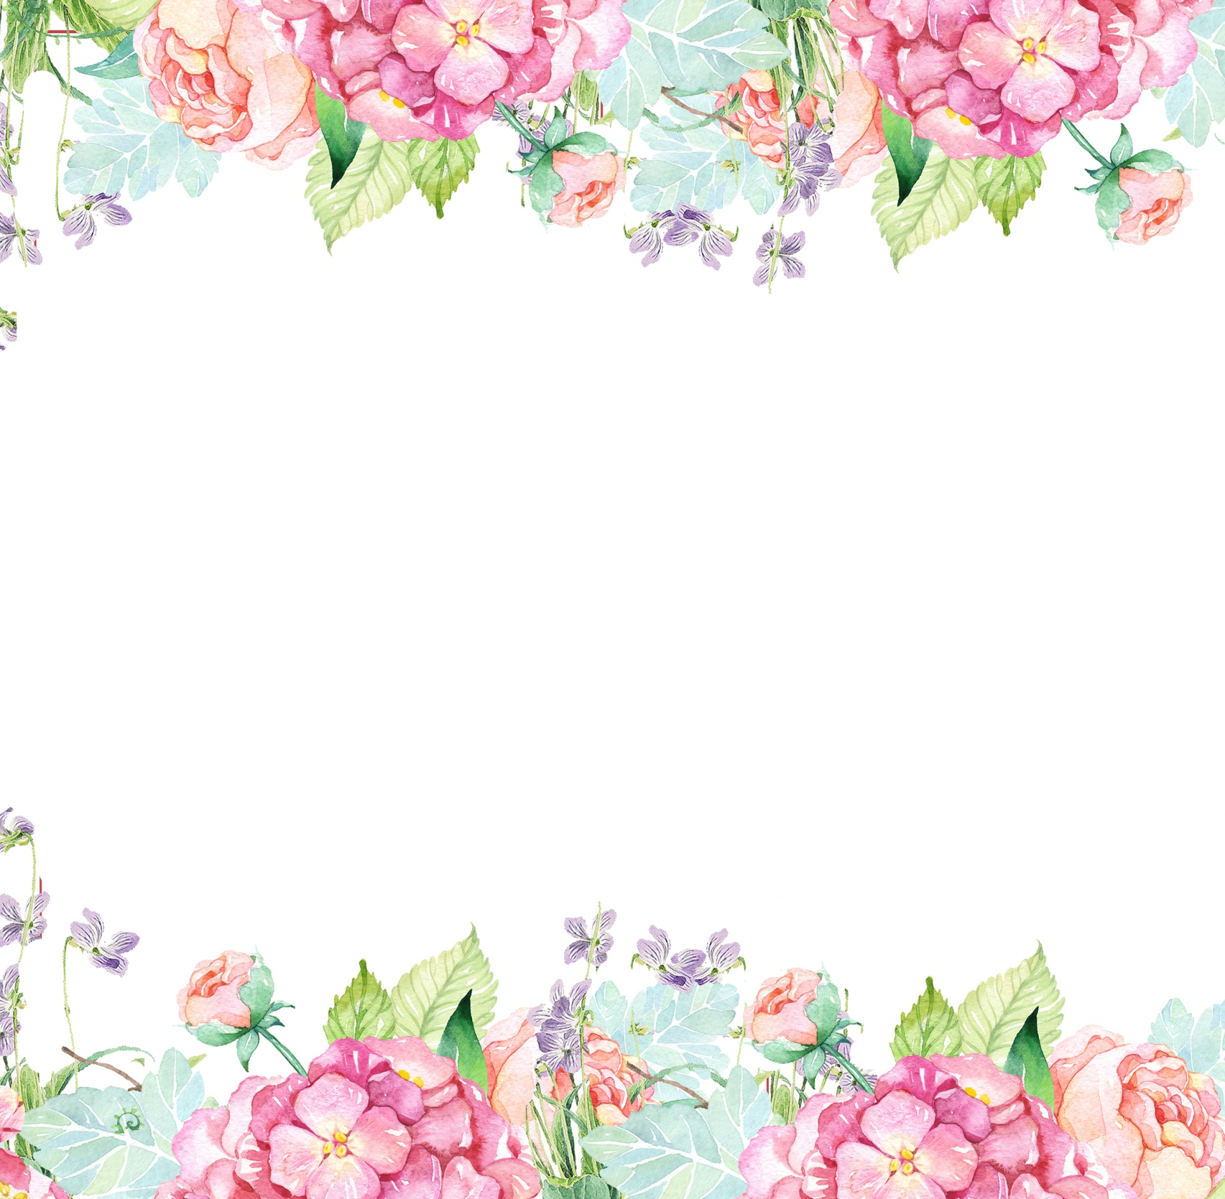

Name: Jenn Pullin (Pickett) Initals: JLP

Birthday: October 22

Preferred t-shirt size? Large

What is your favorite color? Lavender

What is your favorite flower/plant? Wildflowers (anything colorful) and any plant!

Where are your favorite places to shop? Target, Old Navy, Trader Joe’s,

Amazon, Barnes & Noble, Red Eye Coffee Shop

What are your favorite restaurants? Chipotle, Chick-Fil-A, Panda Express. I love trying local restaurants in town!

What do you collect (candles, foxes, etc.)? Vinyl Records, Plants, Stickers

What is your favorite cold drink? Coke or an iced vanilla latte

What is your favorite hot drink? Pumpkin spiced latte or any hot latte!

What is your favorite sweet treat? Reese’s! I am a sucker for chocolate.

What is your favorite salty treat? White Cheddar Cheezits

What is your favorite fruit? Watermelon, grapes, bananas, blackberries

Do you have any food allergies? Nope!

Interests: Reading, hiking, cooking, listening to music, exploring town, going to farmers markets, and trying new things!

UMOJA House: Optimisio

Wish list for your classroom? <https://www.amazon.com/hz/wishlist/ls/1IPSE86ABAAFU?ref_=wl_share>