Ch. 18 Concept Cube

The task:
- Individually, you will complete the cube by selecting ONE of the African states listed below.
  - Mali, Ghana, Ethiopia, Zimbabwe, Swahili City States, or Kilwa

- Research
  - Using multiple sources, examine elements of SPRITE in each civilization
  - Narrow the information down to the top 5 ideas (concepts) that are essential to understanding the organization of this state. These ideas will become the sides of your cube.
    - Each side of the cube must contain at least 3 bullet pointed sentences of information.
  - You must work to assure you have complete and accurate information.

- Organize
  - Sketch it first! One side of the cube must be dedicated to the title. What exactly are you going to have on the other 5 sides of your cube?
  - When designing the cube, you cannot just write words on the sides. Each concept needs to be accompanied by a picture, graph, political cartoons, etc. This may be printed or hand-drawn, but needs to have a direct correlation to the concept.
  - Neatness, color and creativity count.

- Construct your Cube: (can print out cube template from website- just make sure the measurements meet the requirements- or create one using the instructions below)
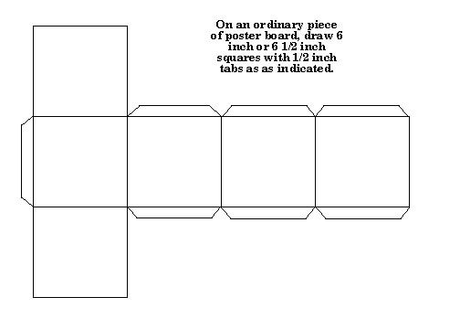
On an ordinary piece of construction paper, draw six 4 inch or 4 ½ inch squares with ½ inch tabs as indicated.
- Fold on the lines above and secure with glue or tape.
- Due Date
  - Your project is due at the BEGINNING of your class period on Thursday 12/13.
  - Late projects will NOT be accepted, so you need to make sure that your group is organized and that the project is ready to go on that date.
  - This project is EXTRA CREDIT

