

Hartsfield Magnet School for International Studies

Media Center Collection Development Plan

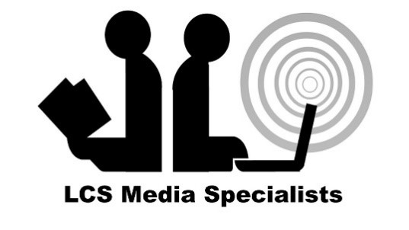

John Olson |  | Katlyn Anderson
John Olson  Principal |  | Katlyn Anderson  Certified Educational Media Specialist

Table of Contents

 | Page
Our Vision and Mission | 3
Leon County Schools Vision and Mission | 3
Hartsfield Vision and Mission | 3
Collection Development Plan Cycle | 4
Hartsfield Collection Development Plan | 5
Knowledge of the Community: School Analysis | 5
Knowledge of Collection: Collection Analysis | 6
Needs Assessment | 8
School Library Purpose/Goals | 9
Materials Section | 9
Acquisition and Processing | 9
Collection Maintenance | 9
Circulation | 10
Collection Evaluation and Inventory | 10

EXECUTIVE SUMMARY

Leon County Schools Vision

The vision of Leon County Schools is to provide an engaging, safe, and respectful learning environment that fosters effective communication, collaboration, and critical thinking while creating productive citizens who value diversity and positively contribute to society.

Leon County Schools Mission
The mission of Leon County Schools is to educate, inspire, and empower all students to become responsible, respectful, and engaged citizens who are equipped with the critical thinking skills needed to thrive in our global society.
_______________________________

Hartsfield Vision
The vison of Hartsfield Magnet School for International Studies is to provide a rigorous and equitable educational experience. It is our responsibility to produce students who are agents of their own learning and are safe to grow academically, socially and emotionally.

Hartsfield Mission
The mission of Hartsfield Magnet School for International Studies is to an facilitate inquiry based instructional model that encourages collaboration and problem solving. We promote international mindedness by developing the ability to connect with others in the interest of acting with compassion to serve the global community.

COLLECTION DEVELOPMENT PLAN CYCLE

This collection development plan is a subsection of the Hartsfield Strategic Plan for Library Media Operations. The collection development plan outlines how district and school funds are to be spent, collection maintenance, and how/when to remove items from the collection. The Hartsfield Collection Development Plan is organized as follows:

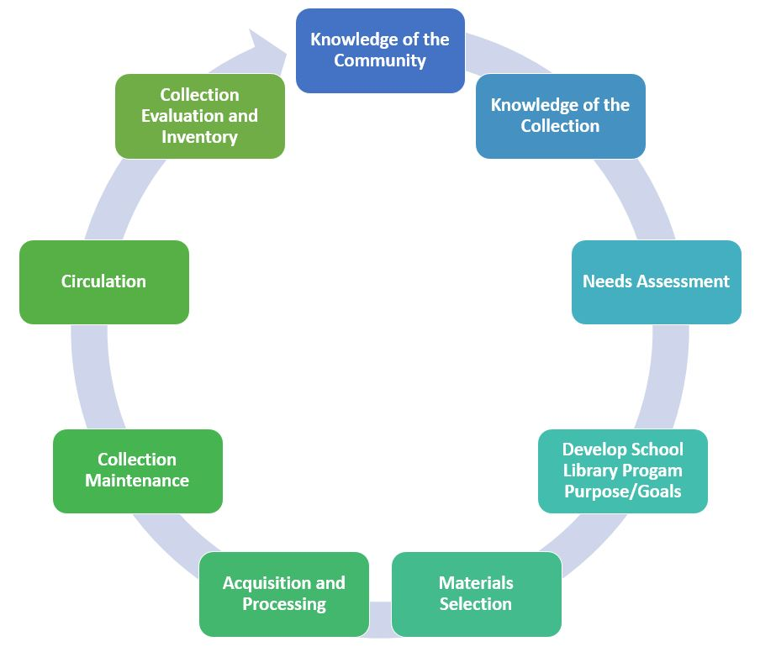

KNOWLEDGE OF THE COMMUNITY

Hartsfield serves 371 students enrolled in grades Pk-5. The student population’s ethnicity is made of 6.5 % Hispanic and 93.5 % Non-Hispanic students. Additionally, we serve a diverse population made up of White 6.5%, Black 71.1%, Native .3%, Asian 2.7%, Pacific 1.3%, and Multicultural 6.5 % students.

The administration includes Principal John Olson and Assistant Principal Rosie Wyatt. Hartsfield is proud to offer the many special programs which provide students with opportunities. These include our IB primary years program, and our Spanish language class and our after-school robotics club.

School Analysis

The school analysis provides an overview of the school’s enrollment, demographics and special programs offered.

Enrollment & Demographic Data
371  2025-26 Student Enrollment as of August 31, 2025 |  | Subgroups |  | Federal Ethnicity
 |  | 2.7 %  ELL | 15.9 %  ESE | 6.5%  Hispanic | 93.5 %  Non-Hispanic
Federal Race Category
6.5%  White | 71.1%  Black | .3%  Native | 2.7 %  Asian | 1.3 %  Pacific | 6.5%  Multicultural
Proficiency Data
Assessment | 2024-25 | 2023-24 | Assessment | 2024-25 | 2023-24
FSA ELA  Grade 3 | 22% | 34% | FSA Math  Grade 3 | 52% | 57%
FSA ELA  Grade 4 | 35% | 40% | FSA Math  Grade 4 | 35% | 50%
FSA ELA  Grade 5 | 33% | 23% | FSA Math  Grade 5 | 43% | 27%
NGSSS Sci 5 EOC | 36% | 13%

KNOWLEDGE OF COLLECTION

Collection Analysis
A thorough analysis of the current media center collection at Hartsfield indicates that the average age of the collection is 22 years and the number of books per student is 37.8. The American Association for School Libraries has established a criterion for highly effective media center that includes a ratio of 15-20 books available per student in the collection. The suggested ration ensures that students are not overwhelmed with choice and are able to select books that they want to read. The current age of our collection suggests that our nonfiction section may contain outdated and inaccurate information as well as the fiction section may be losing its relevancy with our students.

At this time, Hartsfield does not meet the recommended standards for the number of books per student. The collection is developed for and influenced by students, their interests, academic needs, and alignment to the curriculum. The data below is a snapshot of the collection based on a Titlewise Analysis.

 |  |  |  |  |  | 
14,637  Items in the Collection |  |  |  | 57%  Fiction Titles in the Collection |  | 43%  Nonfiction Titles in the collection
Library media resources are curated to include both recently published works and classics that both rightfully impact the average age of the collection. |  |  |  |  |  | 
 |  |  |  | 71%  Aged Titles |  | 4%  Newer than 5 Years
 |  |  |  | Student Wellbeing library media resources can contribute to character development.
 |  |  |  | 
35%  Representative Titles  in Collection |  |  |  | 45%  SW Titles in Collection |  | 21 years  SW Titles Average Age
 | 99 | 422 | 1481 | 4,020 | 3,206 | 1,193 | 16
 | BR-199 Lexile Items | 200-349  Lexile Items | 350-499  Lexile Items | 500-674  Lexile Items | 675-909  Lexile Items | 910-1299  Lexile Items | 1300+  Lexile Items
Collection Analysis by Category

The information collected in this section provides a detailed look at the current library collection by classification and genre. The information was gathered from Follett Destiny, the library management system, and Titlewave, the vendor’s ordering and analysis tool.

Section | # of Titles | Average Age
Computer Science, Information & General Works | 41 | 22 yrs.
Philosophy & Psychology | 67 | 23 yrs.
Religion | 62 | 27 yrs.
Social Sciences | 859 | 26 yrs.
Language | 82 | 27 yrs.
Science | 1,101 | 23 yrs.
Technology | 394 | 23 yrs.
Arts & Recreation | 556 | 20 yrs.
Literature | 429 | 29 yrs.
History & Geography | 711 | 24 yrs.
Biography | 628 | 22 yrs.
Easy | 4,328 | 23 yrs.
General Fiction | 4,450 | 21 yrs.
Graphic Novels | 207 | 7 yrs.

The analysis of the collection also revealed the following areas of strengths and concerns
- Weakness Non-fiction
- Strength Graphic Novels

Representation Analysis

To deepen focus on strategic collection development, specific sections of the collection were analyzed in detail to determine whether the media center collection reflects and represents various points of view and experiences. The goal is to provide a balanced collection that can be both a mirror, to reflect a reader's experience, and a window, so readers can experience different viewpoints.

Results
Based on the available school data of Hartsfield in comparison to Collection Analysis results, it was found that:

Representation Focus | Avg. Age of Target Population Titles | # of Target Population Titles | % of Target Population Titles | % of Students
African American | 19 years | 883 | 6% | 71.1%
Poverty | 26 years | 83 | .56% | 100%
Physical Disabilities and Special Needs | 21 years | 180 | 1.3% | 15.9%

Summary
After completing a deeper, targeted analysis of the representation section of the TitleWise report, it was determined that:

- We need to increase the number of books in the sections listed above after weeding.
- We need to add newer titles to the sections listed above after weeding.
- We need to weed the sections listed above this year and next year to ensure no books were overlooked.

Needs Assessment
After sending a survey to our teachers and students we received the following feedback, mostly verbal responses. Students were asked the questions verbally and wrote down their answers. Six out of 29 teachers said they would like more books for students who read at a kindergarten or first grade AR level. One out of 29 teachers mentioned she would like more books written in foreign languages. Seven out of 29 teachers said they would like more relevant books in our nonfiction section. A majority of students in grades 2-5 stated they would like more relatable books in the nonfiction section and when asked to describe the current collection most used the word old. A majority of students in grades 3-5 stated they would like more graphic novels.

Materials Selection
Hartsfield library media center is under the umbrella of the Leon County Schools district library program which in turn, follows requirements laid out by Florida law for library media centers and instructional materials.
Per FS 1006.28.6(d)2.a-d and LCS po2520, the guidelines below are general standards by which to review and select materials to meet the needs of your students, faculty, and staff.
Materials considered for purchase are selected on the basis of the following criteria. The materials must be:

Library Materials Selection Guidelines
- In support of state academic standards and aligned curriculum. | - suited to student needs and their ability to comprehend the material presented.
- able to meet an academic need of students and faculty. | - of quality of writing and production.
- free of pornography and material prohibited under s. 847.012. | - appropriate for the grade level and age group for which the materials are used or to whom they are made available.
- at an appropriate readability level and user appeal. | - valid, accurate, objective, up-to-date, and appropriate information
Effort should be made to keep the media current, comprehensive, and include media that reflects rapidly developing instructional technologies.
After analyzing the Hartsfield library media collection, the following areas have been selected as the primary areas of emphasis for materials selection for the 2025-2026 school year.
Area 1: Nonfiction
Area 2: Easy Reader Lexile level BR- 349
Area 3: Books that represent our diverse population
Notes/Rational: Overall our nonfiction section needs improvement and each section housed within it is well above the average age based on the ALA standards. Several teachers and students have noted that we do not have many books that are written in a lower Lexile level, and our data reflects this statement as well. Much of our student population is African American but this is not reflected in our books.

Acquisition, Processing, and Maintenance

Acquisitions Procedures

In selecting learning resources, professional personnel will evaluate available resources, and curriculum needs and will consult reputable, professionally prepared aids to selection, and other appropriate sources. The actual resource will be examined whenever possible.
- Recommendations for purchase involve administrators, teachers, students, district personnel, and community members, as appropriate.
- Selection is an ongoing process that should include removing materials that are no longer used or needed, adding materials, and replacing lost and worn materials that still have educational value.

Circulation

Circulation guidelines and procedures for Hartsfield
Students in kindergarten and first grade are only allowed to check out one book at a time during their weekly class visits. Students in second grade may check out one book at a time during the first semester and two books at a time during the second semester. Students in third, fourth, and fifth grade may check out two books at a time. Students in second through fifth grade may check out books during their weekly visits and/or on Thursdays. If students come on Thursday, they only have 10 minutes to find a book. Books are reshelved on Thursdays by the media specialist. When lost or damaged books occur, students are limited to one book at a time, and they may not check out new arrivals until they show they can follow expectations again.

Circulation statistics for Hartsfield library media center area as follows:

School Year  [2024-25] | Circulation Statistics
School Year  [2024-25] | Kindergarten | 1st | 2nd | 3rd | 4th | 5th
All genres | 49 | 711 | 1375 | 832 | 940 | 1178
Totals | 5,085

Collection Evaluation and Inventory

Weeding, also known as Deselection, is a valuable professional practice for the Hartsfield school library media center.

This page lists the priorities for selection and weeding for each school year and includes the action, updates, and outcomes. This is subject to change due to funding and time constraints.

School Year | Strategic Focus
2025-26 | Selection Priorities  - Nonfiction  - Easy readers Lexile level BR- 349  - Diverse Books about African American culture
2025-26 | Weeding Priorities  - Literature  - Science  - Language
2026-27 | Selection Priorities  - Nonfiction  - Easy readers above Lexile level 349  - Fiction books around Lexile level 349
2026-27 | Weeding Priorities  - Social Science  - Religion  - History and Geography

Budget and Purchasing Plan

This page outlines the current budget available and specifically lists the priorities for this school year (2025-2026).

Annual Budget 2025-2026

State Funds
Source | Amount
State Allocation | 2,305.06
Internal Accounts
Source | Amount
Book Fairs | 2,000
School Support | 0
TOTAL | 4,305.06

Purchasing Plan 2025-2026

Approximate Purchasing Plan
Purpose | Amount
SSYRA books | 693.21
Non-fiction | 2,000
Easy Reader Lexile level BR- 349 (Books at a kindergarten and 1st grade reading level. | 1,700
ABDO reference online | 249.95
Supplies for the Media center (book repair, AR rewards) | 355.11
TOTAL | 4305.06

