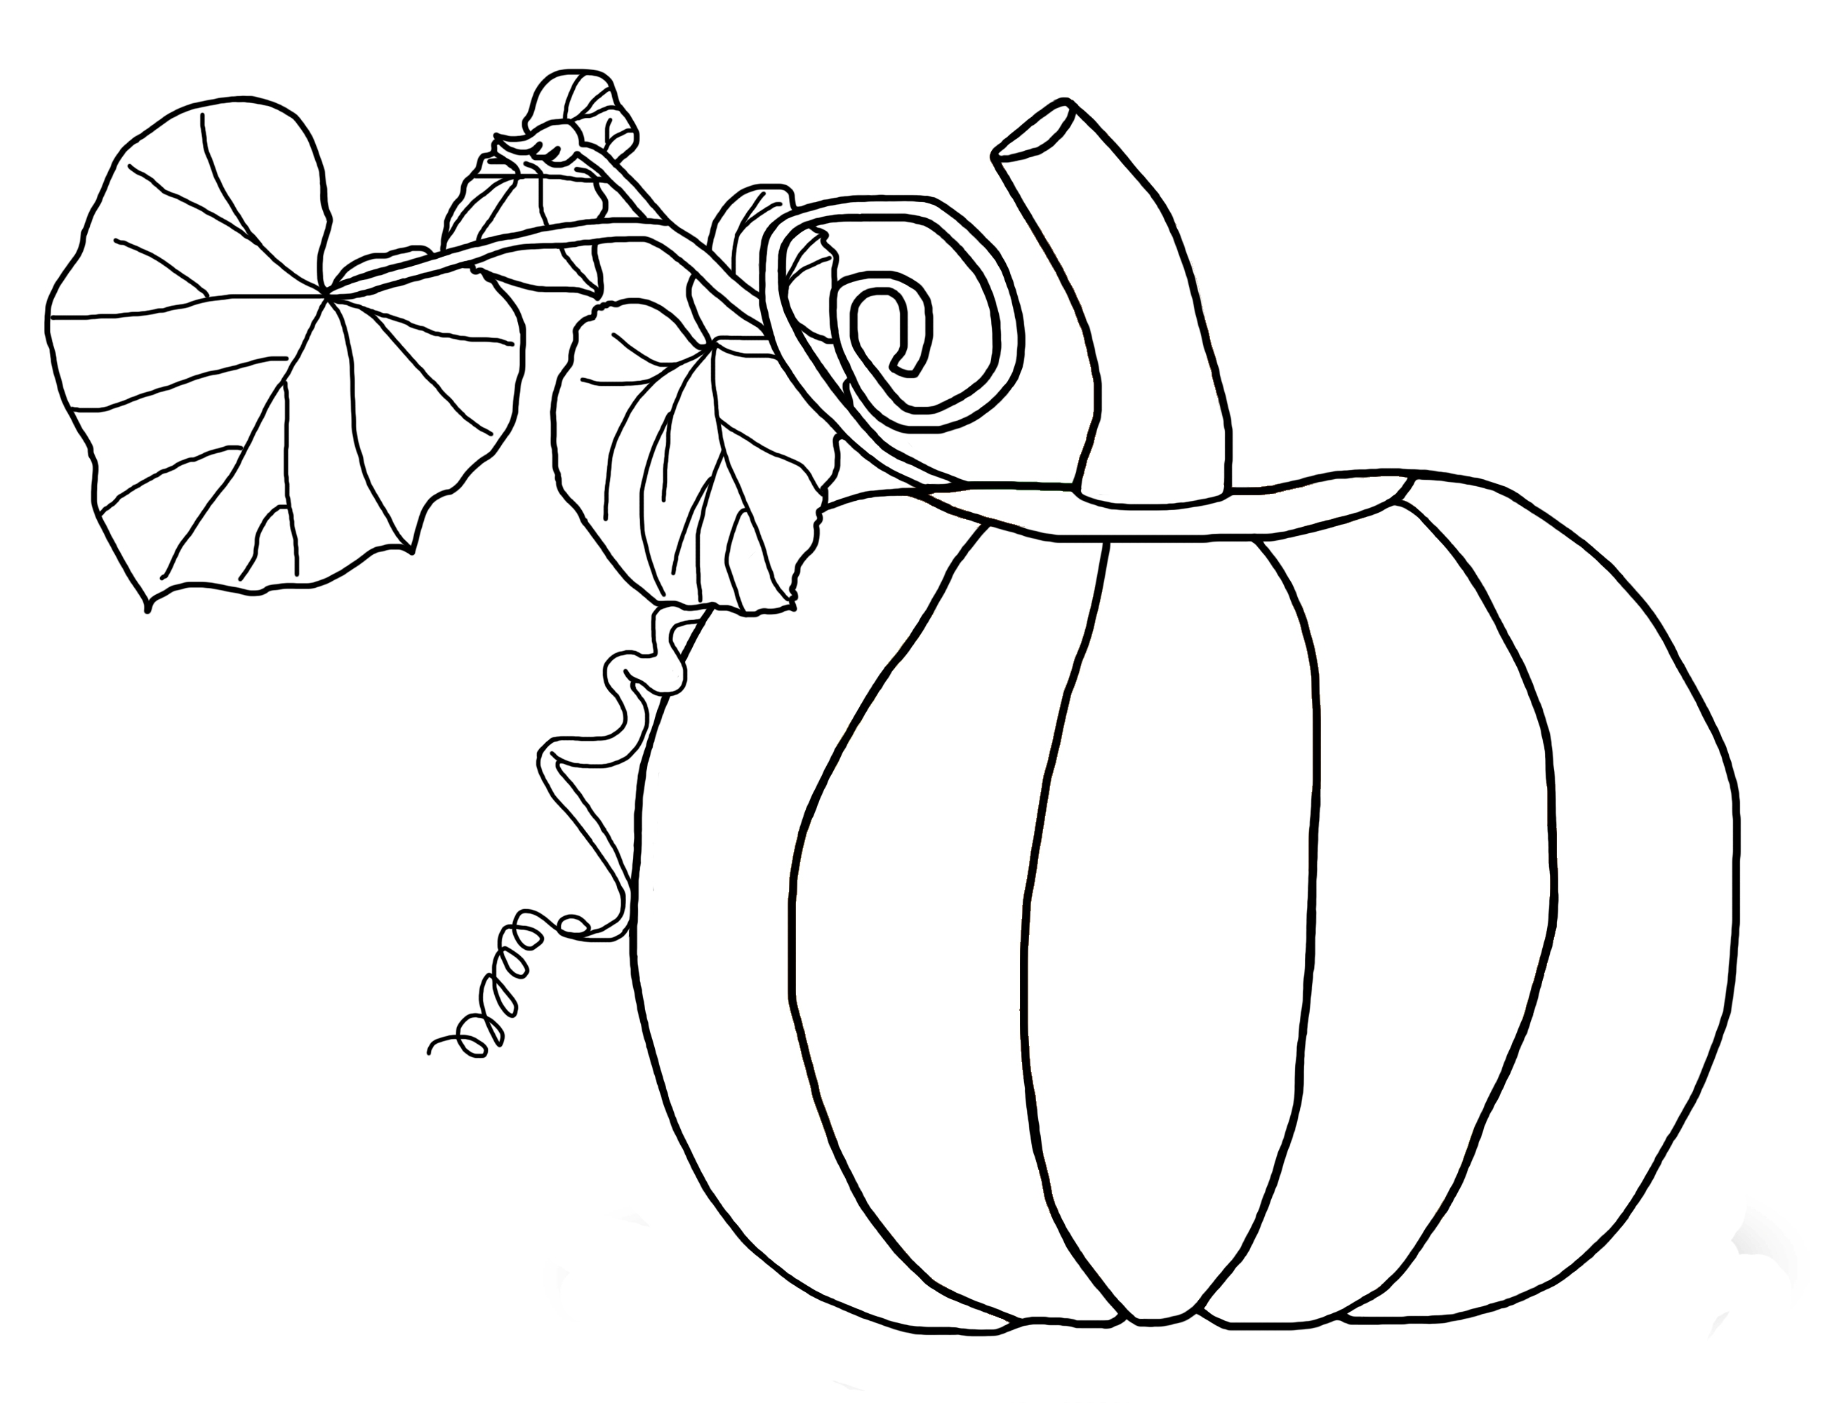
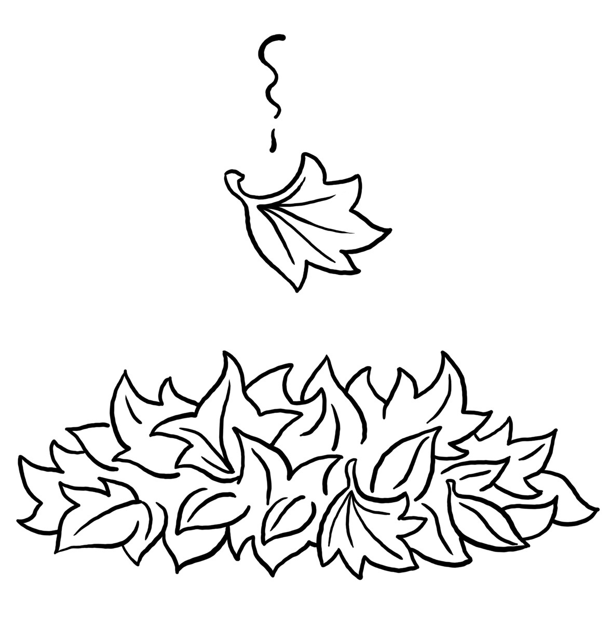

The Kindergarten Connection
October 2024

SAVVAS Reading Themes

Unit 1 – Going Places!

How Can We Describe Special Places?

Project-Based Learning: Let’s Go!

Unit 2 – Living Together: What Do Living Things Need?

Animals on the Move-Why do some animals move from place to place?

From Nectar to Honey-How do some living things make what they need?

UFLI for Phonological Awareness/Word Work

VC/CVC Word Building and Blending, Generating Letter Sounds with Proper Mouth Placement
Language Arts
Genres: Informational Text, Fiction
Animal Names
Parts of a Book
Letters: Ii, Aa, Oo, Dd, Cc, Uu, Gg
Writing: Personal Narrative/Complete a sentence.
Sight word recognition:
A, I, the, and, is, as, said, to, do
Math
Compare Numbers Through 5
Count and Represent Numbers Through 8
Count and Represent Numbers Through 10
Science
Making Observations, Physical Science,
States of Matter
Social Studies
Hawks Rise Character Traits, Hispanic Heritage, Bully Prevention, Red-Ribbon Week

Important Dates

10/4 First Friday/Friendship Lunch

10/9 Reading Rally Logs Due

10/10 Fall Picture Day

10/18 End of 1st 9 Weeks

10/21 NO SCHOOL – Teacher Planning Day

10/22 Beginning of 2nd 9 weeks Kindergarten grading begins

10/25 Pumpkin Family Projects DUE *More Info to Come*

10/28 Red Ribbon Week

10/31 Fall Party/ Dress-Up Day wear black and orange or pumpkins

Reminders

Please send a seasonal change of clothing labeled with your child’s name along with daily snack and water thermos/bottle

The Kindergarten Teachers,

Mrs. Campbell, Mrs. Deason, Ms. Hammond, Mrs. Rockwood, Mrs. Lindsey, Ms. Lindquist

Mrs. Ramos, Ms. Randall

