***Reading Guide—Ch. 13***

***Reformation and Religious Warfare in the 16th Century***

***Reading Guide—The Northern Renaissance (p. 346-348)***

1. Background
   1. How and when did the Renaissance spread to the northern states of Europe?
2. Christian Humanism
   1. Similarities with the Italian Renaissance
   2. Differences with the Italian Renaissance
   3. General Characteristics of the Northern Renaissance

D. Impact of the Northern Renaissance

1. The Christian Humanists

*Fill in the following chart:*

|  |  |  |  |
| --- | --- | --- | --- |
| **Christian Humanists** | **Background** | **Major Works (Date)** | **Ideas and Significance** |
| **Desiderius Erasmus** |  |  |  |
| **Sir Thomas More** |  |  |  |

***Prelude to Reformation***

1. Background—Briefly review the main ideas of the Christian Humanist movement.
2. Prelude to Reformation: Church and Religion on the Eve of the Reformation
   1. Abuses of the Clergy
   2. Popular Religion—Expressions of Religious Piety
      1. Explain the mechanical view of the process of salvation in regard to relics and indulgences.
      2. The Modern Devotion
         1. What was it?
         2. ID Thomas a Kempis and *The Imitation of Christ*
         3. explain the impact of popular mysticism and its relationship with the orthodox practices of the Roman Catholic Church
         4. How did this new religious piety lead to disillusionment with the Church?

***Martin Luther and the Reformation in Germany***

1. The Early Luther
   1. Background Information about Luther
   2. Explain Luther’s concept of “Justification by Faith”
   3. Explain the increase in the sales of indulgences
      1. Why was Luther so distressed by this?
   4. The Ninety-Five Theses
   5. The Leipzig Debate
   6. Pamphlets of 1520
   7. The Diet of Worms (1521)
2. The Rise of Lutheranism
   1. The Urban Spread of Luthernaism
   2. use of woodcuts
   3. Crises of the mid-1520s
      1. radical reformers
      2. Christian Humanists
      3. ID The German Peasant’s War and Thomas Muntzer. Include Luther’s reaction.
      4. Explain why Luther was so dependent on the state.
3. Church and State
   1. What doctrines had Luther changed from Catholicism and why?
   2. Explain the concept of National Churches in regards to the Lutheran churches.

***Germany and the Reformation: Religion and Politics***

1. Charles V (1519-56)
   1. Background
   2. His Four Major Challenges
      1. The Hapsburg-Valois Rivalry
      2. the Papacy
      3. the Turks
      4. Germany’s Internal Situation
         1. HRE internal political situation
         2. Diet of Augsburg (1530)
         3. the Schmalkaldic League
         4. Peace of Augsburg (1555)

***The Spread of the Protestant Reformation***

1. Scandinavia
   1. Sweden
   2. Denmark and Norway
2. Ulrich Zwingli
   1. Explain the make up of the Swiss cantons
   2. Zwingli’s Life
   3. What was a disputation?
   4. Compare and Contrast Zwinglism with Lutheranism
   5. Explain the growth of Zwinglism
   6. The Marburg Colloquy (1529)
   7. Swiss Civil War in 1531
3. The Anabaptists
   1. Who were they?
   2. Common Ideas?
   3. Persecutions
   4. The Fiasco at Munster (early 1530s)
   5. Menno Simons and the Mennonites
4. The Reformation in England

Henry’s Divorce and the Separation from Rome

* 1. Important Personalities
     1. ID Cardinal Wolsey
     2. ID Thomas Cranmer (Archbishop of Canterbury)
     3. ID Thomas Cromwell
     4. ID Anne Boleyn
  2. The Act of Supremacy (1534)
  3. Cromwell’s Dissolution of the Monasteries
  4. Henry’s Other Wives
  5. Edward VI’s Religious Policies (1547-53)
  6. Mary I’s Religious Policies (1553-58)

1. John Calvin and the Development of Calvinism
   1. Background and his Conversion
   2. *The Institutes of the Christian Religion* (1536)
   3. Calvinist Doctrine—How did it compare/contrast with Catholicism and the other Protestant religions?
   4. Calvinist Organization in Geneva
      1. Ecclesiastical Ordinances
      2. The Genevan Consistory
      3. The Spread of Calvinism

***The Social Impact of the Reformation***

1. The Effect on Families
   1. Similarities with Catholicism
   2. Changes to the conception of the family
   3. The role of women
2. Education in the Reformation
   1. How did the Protestant schools differ from the humanist schools?
   2. The Gymnasium
   3. The Genevan Academy
   4. The Jesuits as Educators
3. Religious Practices and Popular Culture
   1. The Decline of “Superstitious Customary Practices” Among Protestants
   2. Reform of Other Social Practices

***The Catholic Reformation***

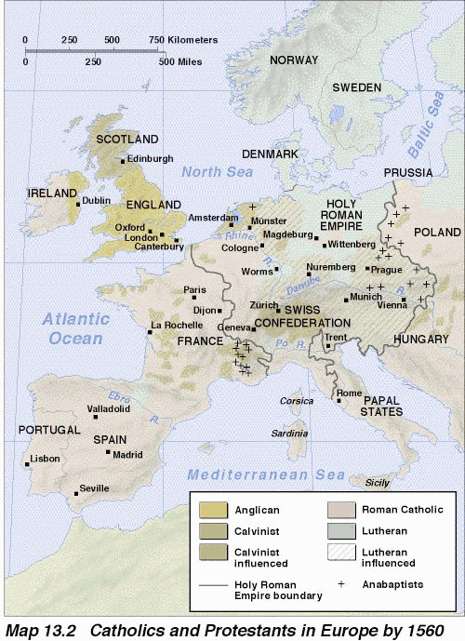

1. Geography
   1. Using the above map, where were the following religions dominant and/or influential? Be sure to differentiate between the two.
      1. Anglican
      2. Calvinist
      3. Roman Catholic
      4. Lutheran
      5. Anabaptists
2. Background to the Catholic Reformation (Counter Reformation)
   1. The Emergence of a New Mysticism
      1. Teresa of Avila
   2. Regeneration of Religious Orders
   3. New Religious Orders and Brotherhoods
3. The Society of Jesus
   1. Ignatius of Loyola (Background) and *The Spiritual Exercises*
   2. The Papal Bull of 1540 and the organization of the Jesuits
   3. Major Activities

1. Who were Francis Xavier and Matteo Ricci?

D. Significance and Impact

1. A Revived Papacy
   1. Policies of Paul III
   2. Paul IV and the Inquisition
2. The Council of Trent (1545-1563)
   1. Goals?
   2. Early Conflicts
   3. Reaffirmation of Basic Catholic Doctrine
   4. Reform

E. Impact

***Politics and Wars of Religion in the 16th Century***

1. The French Wars of Religion (1562-1598)
   1. Background—Why had France seemed an unlikely place for a religious war?
   2. Explain the social make up of the Huguenots
   3. Explain the policies of Catherine de Medici
   4. Catholics v. Protestants

**Fill in the following chart:**

|  |  |  |  |
| --- | --- | --- | --- |
|  | **Huguenots** | **Politiques** | **Ultra Catholics** |
| Leaders |  |  |  |
| Goals |  |  |  |
| Supporters |  |  |  |

* 1. The Wars
     1. Outbreak
     2. St. Bartholomew’s Day Massacre (1572)
     3. the formation of the Holy League
     4. War of the Three Henries (1588-1589)
     5. Henry IV (of Navarre)
     6. Edict of Nantes (1598)

1. Philip II, the Most Catholic King of Spain (1556-1598)
   1. List and explain the major goals, actions, and results of the reign of Philip II
      1. Goals

* + 1. Actions—Domestic and Foreign Affairs
    2. Results
  1. Revolt of the Netherlands
     1. Background
     2. Causes
     3. Actions
     4. Important Figures
     5. Results

1. Elizabethan England
   1. General Achievements
   2. Religious Policy—The Elizabethan Settlement of 1559
   3. Two Significant Minorities and their actions
      1. Catholics
      2. Puritans
   4. Domestic Policies
   5. Foreign Affairs