**ALGEBRA 2 WS 10.4 B ELLIPSES**

**Write each equation in standard form and find the center, foci, length of the major and minor axis, vertices, & co-vertices.**

1. 
2. 
3. 
4. 

**Write an equation of an ellipse with each set of characteristics.**

1. Major axis from (0, 2) to (0, -2) and minor axis from (1.5, 0) to (-1.5, 0)
2. Vertices at (0, 4) and (0, - 4); foci at (0, 2) and (0, - 2)

**Write an equation of an ellipse with each set of characteristics.**

1. Foci at (8, 0) and (-8, 0); length of major axis equals 30
2. Vertices at (-7, 0) and (7, 0); length of minor axis equals 48
3. Vertices at (-10, 0) and (10, 0) and eccentricity *e* is 
4. Center at (0, 0), one focus at  and eccentricity *e* is 
5. 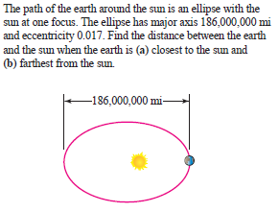

**Write an equation for the ellipse:**

1. 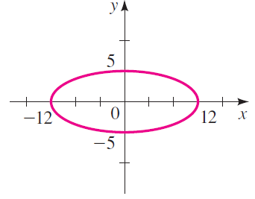
2. 