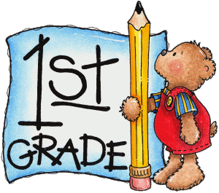

**Week 6 Quiz**

Directions: Complete and submit for your weekly quiz and participation grade. This can be done by taking a picture and sending it via Remind, Teams or teacher’s email. (Please refer to videos and Week 6 packet.)

**ELA- Read and answer the following questions.**

**Lark and Martin**

Lark sees an ant. She grabs it with her beak. “Tasty!” says Lark. A flock of geese flies by. Then Martin flies to Lark from the creek. “Did you see any fish you like?” Lark asks Martin. “No,” he says. “Did you find anything good to eat?” she asks. “Ants and flies,” he replies. “Seeds are tasty, too,” says Lark. She picks up a seed. “Yuck,” says Martin. “Seeds are hard.” Lark wants Martin to eat seeds, too. “How can you eat in winter if you eat only insects?” she asks. A large car arrives. Two men and four kids get out. “The park must be open,” says Martin. They are too close. Lark and Martin fly to a tree. Soon it is winter. Lark opens a jar. It is full of seeds she collected. Martin has none. Lark eats seeds. Martin wishes he had food. Anything would taste good right now. Lark gives him some seeds. “Yum!” says Martin. “Maybe I can put seeds in a jar, too!”

1.How do you know that Lark likes to eat ants?

a) She says “Tasty!”

b) She puts them in a jar.

c) She asks Martin if he likes fish.

2.What word helps you know how Martin feels about seeds?

a) small

b) tasty

c) yuck

3.Lark thinks Martin should save seeds so he can_____.

a) keep the park clean

b) have food to eat in the winter

c) share his food with her in the park

**Math-Read and answer the questions.**

1. A cylinder has _______ flat surfaces.
2. A rectangular prism has _______ flat surfaces.
3. A cone has _______ flat surface.
4. A cube has _______flat surfaces.

**Science- Read and complete**

What covers most of the planet?

1. dirt
2. water
3. salt

**Social Studies**

Who lives in the White House?