Here are the web links or QR codes to access the digital summer homework resources. You will have to print the digital resources for use. I have provided all the paper materials that were requested. Happy Summer!

1st Resource- <https://www.leonschools.net/Page/35419>

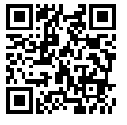

2nd Resource- <https://www.leonschools.net/Page/35559>

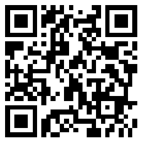

Handwriting Practice Resource- <https://www.leonschools.net/Page/33792>

