***Reading Guide—Chapter 15***

***State Building and the Search for Order in the 17th Century***

***Background—Social Crises***

1. Economic Stagnation
2. Population Trends

***The Witchcraft Craze***

1. Background
2. The Accused and the Trials
3. Explanations

V. Witch Stereotypes

1. The Waning of the Witchcraft Hysteria (Why?)

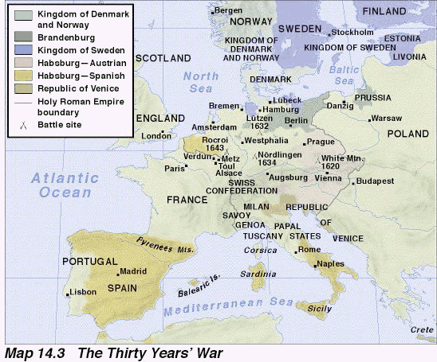

***The Thirty Years’ War (1618-1648)***

1. Causes
   1. French-Hapsburg Rivalries
   2. Religious Motivations
   3. Controversies over German Liberties
2. Four Major Phases—Actions, Important Personalities, and Results
   1. Bohemian (1618-25)
   2. Danish (1625-29)
   3. Swedish (1630-35)
   4. Franco-Swedish (1635-48)
   5. What were the provisions and the impact of the Peace of Westphalia (1648)?
3. A Military Revolution
   1. Greater Fire Power
   2. Flexibility and Mobility
   3. Discipline
   4. Impact on European History
4. Rebellions
   1. Background
   2. Peasant
   3. Noble
   4. Commoners

***The Theory of Absolutism***

Jean Bodin’s Theories

II. Bishop Jacques Bousset—*Politics: Drawn from the Words of Holy Scripture*

III. Theory v. Reality

***Absolutism in Western Europe***

I. France and Absolute Monarchy

A. Foundations of French Absolutism

1. Background

1. Cardinal Richelieu’s Centralization of Power under Louis XIII (1624-1642)

a. Huguenots

1. nobility
2. network of spies
3. intendant system
4. Foreign Policy

3. Cardinal Mazarin during the Minority of Louis XIV (1642-1661)

a. Background

1. ID the Fronde
2. The Reign of Louis XIV (1643-1715)

1. Routine of the “Sun King”

1. France’s Bewildering Feudal Overlaps
2. Control of State
3. Edict of Fountainebleau
4. Finances and Jean Baptiste Colbert
5. Versailles
6. the Wars of Louis XIV

a. Marquis de Louvois and the Army

1. Franco-Dutch Wars
2. ambitions against the Holy Roman Empire
3. The War of the League of Augsburg (1689-97—also known as the Nine Years’ War)
4. The War of the Spanish Succession (1702-1713)

1. ID the Peace of Utrecht

1. Louis’ Legacy to France

The Decline of Spain

A. Weaknesses by the end of the reign of Philip II

1. Philip III (1598-1621)
2. Philip IV (1621-65)

***Absolutism in Central, Eastern, and Northern Europe***

1. Explain Voltaire’s Description of the Holy Roman Empire after 1648.
2. Brandenburg-Prussia and the House of Hohenzollern

A. Background

1. Frederick William, the Great Elector (1640-88)
2. Elector Frederick III (who becomes King Frederick I—1688-1713)
3. Austria and the House of Hapsburg
4. Background
5. Leopold I (1685-1705)

**DOMESTIC ISSUES**

**FOREIGN AFFAIRS**

1. Italy
2. Muscovy Becomes Russia

A. Ivan IV, the Terrible

1. Times of Trouble
2. Muscovite Society
3. Peter the Great—Domestic Issues
4. Peter the Great—Foreign Affairs
5. Scandinavia

A. Denmark

1. Sweden and the House of Vasa
2. The Ottoman Empire

A. The Victories of Suleiman I, the Magnificent

1. Battle of Lepanto (1571)
2. Domestic Affairs
3. Foreign Affairs after 1600
4. Explain the Limits of Absolutism

***Limited Monarchies and Republics***

1. Poland
2. the Golden Age of the Dutch Republic
3. The Emergence of Constitutional Monarchy in England

A. James I and relations with Parliament

1. Charles I and relations with Parliament

1. ID the Petition of Right

1. ID Ship Money
2. Explain Charles’ religious policy and his work with William Laud
3. Scottish rebellion
4. Prelude to Civil War

1. Long Parliament and legislation

1. Immediate Cause of the Civil War
2. The Civil War (1642-46)

1. Sides???

1. Oliver Cromwell and the New Model Army
2. Results
3. Split of Parliament and creation of the Rump Parliament
4. Cromwell’s Commonwealth (or military dictatorship)
5. The Restoration (1660)
6. Charles II, the Merry Monarch (1660-85)
7. Development of Political Parties
8. James II (1685-88)
9. ID the Glorious Revolution (1688)
10. Responses to the English Revolution

A. Thomas Hobbes

1. John Locke

***The Flourishing European Culture***

***The Changing Forces of Art***

1. Art: Mannerism and Baroque
   1. Mannerism
      1. ID and distinguish it from Renaissance Art
      2. El Greco
   2. Baroque
      1. ID and distinguish it from Mannerism
      2. How was it part of the Catholic Reformation?
      3. Peter Paul Rubens
      4. Gian Lorenzo Bernini
      5. Artemisia Gentileschi
   3. French Classicism
      1. Background
      2. Nicholas Poussin
   4. Dutch Realism
      1. Background
      2. Judith Leyster
      3. Rembrandt van Rijn
2. A Golden Age of Literature in England and Spain
   1. England
      1. William Shakespeare
   2. Spain
      1. Theater—Lope de Vega
3. Theater—French Neo-Classicism

A. How did the work of the French playwrights differ than that of the English and the Spanish?

1. Explain French Neo-Classicism
2. Jean-Baptiste Racine’s Greek Tragedies
3. Jean-Baptiste Moliere’s Satires