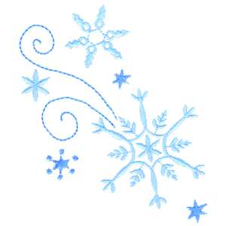

Kindergarten

Connection

January 2019

Language Arts:

**Letters:** Hh, Ee, Ff, Rr, Bb, Ll

**Writing and Grammar:** Organization/Voice

Pronouns/Nouns

**Sight Word Recognition:** My, are, with, he, is, little, she, was

Wonders Themes:

How Does Your Garden Grow?

Trees

Fresh From the Farm

The Four Seasons

Important Dates:

January 8: Students Return

January 11: First Friday

January 16: Report Cards Go Home

January 21: NO SCHOOL – MLK, Jr. Day

January 23: Class Picture Day

January 31: 100th Day of School

Go Math:

Chapter 6: *Subtraction*

Science/Social Studies:

Forms of Energy, Sounds and Vibration

Martin Luther King, Jr.

Thank you!

Thank you for your ongoing support this year. We appreciate the numerous volunteer hours given both at home and at school.

**The Kindergarten Team**

Mrs. Lindsey, Mrs. Hendrick

Mrs. Klawinski, Ms. Randall,

Mrs. Smiley, Mrs. Ramos