**Algebra 2 Spring 2019 Exam Review Answer KEY**



|  |  |
| --- | --- |
| **axis of symmetry** |  |
| **vertex** |  |
| **y-intercept** |  |
| **symmetric point** |  |

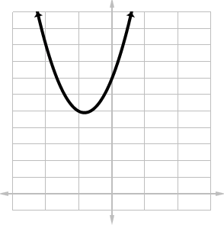

1. interval notation: 
2. 
3. 
4. discriminant = 244  
   2 irrational roots
5. 
6. 
7. 
8. 
9. 
10. 
11. 
12. 
13. 
14. 
15. 
16. 

1. 
2. 
3. 

1. 
2. 
3. 
4. 

1. 
2. 
3. 
4. 

|  |  |
| --- | --- |
| **hole(s)** |  |
| **VA** |  |
| **HA** |  |
| **y-intercept** |  |
| **x-intercept** | none |



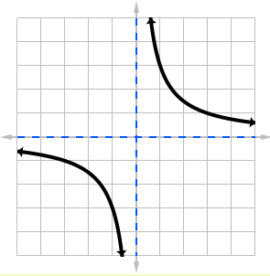

1. 
2. 
3. 
4. 
5. 
6. 
7. 
8. 
9. 
10. 
11. 
12. 
13. 
14. 
15. 
16. 
17. 
18. 
19. 
20. 
21. center    
    radius 9 units
22. 

|  |  |
| --- | --- |
| **center** |  |
| **foci** |  |
| **vertices** |  |
| **co-vertices** |  |
| **major axis** | 10 units |
| **minor axis** | 8 units |
| **eccentricity** |  |

1. 