**AP European History**

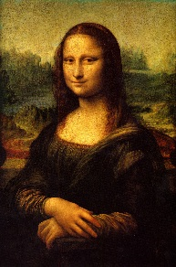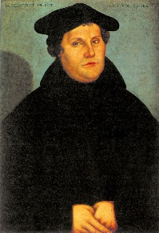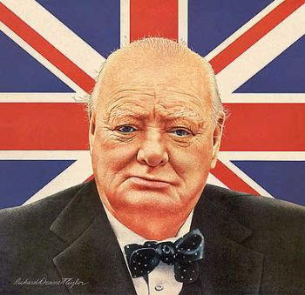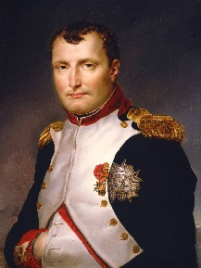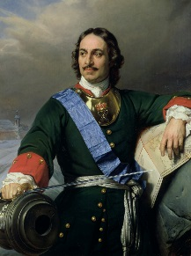

Chiles High School Mr. McNeil

**Course Description**  (from the Curriculum Framework)

AP European History (APEH) focuses on developing students’ abilities to think conceptually about European history from approximately 1450 to the present and apply historical thinking skills as they learn about the past. Five themes of equal importance—Interaction of Europe and the World, Poverty and Prosperity, Objective Knowledge and Subjective Visions, States and Other Institutions of Power, and Individual and Society—provide areas of historical inquiry for investigation throughout the course. These require students to reason historically about continuity and change over time and make comparisons among various historical developments in different times and places.

The goals of this class are to develop (a) an understanding of the principal themes in modern European history, (b) an ability to analyze historical evidence, and (c) an ability to analyze and express historical understanding in writing. The content of the course follows Advanced Placement guidelines of the College Entrance Examination Board; consequently, instruction is given at the college level.

**Expectations**

* Complete reading assignments in a timely and thorough manner.
* Participate in class discussion.
* Pay attention to what I say.
* Stay POSITIVE! This class is taught at a college level; however, Chiles High School students have done well above the national average in this course.

There's no great mystery to doing well in this course.  Read, listen, take notes, try your best, and you will receive a good grade in return and do well on the AP European History exam.

**INSTRUCTION:**

**Themes, Skills, and Topics**

The outlined themes that follow indicate the important areas that might be treated in an APEH course. The ideas suggested do not have to be treated explicitly as topics or covered inclusively, nor should they preclude development of other themes. In addition, questions on the exam will often call for students to inter-relate categories or to trace developments in a particular category through several chronological periods. For this reason, students and teachers need to address periodization in history and to relate periodization, as appropriate, to the following:

**THEMES**

* Interaction of Europe and the World
* Poverty and Prosperity
* Objective Knowledge and Subjective Visions
* States and Other Institutions of Power
* Individual and Society

**SKILLS**

|  |  |
| --- | --- |
| **Skill Type** | **Historical Thinking Skill** |
| I. Chronological Reasoning | 1. Historical Causation |
| 2. Patterns of Continuity and Change over Time |
| 3. Periodization |
| II. Comparison and Contextualization | 4. Comparison |
| 5. Contextualization |
| III. Crafting Historical Arguments from Historical Evidence | 6. Historical Argumentation |
| 7. Appropriate Use of Relevant Historical Evidence |
| IV. Historical Interpretation and Synthesis | 8. Interpretation |
| 9. Synthesis |

# Classroom Procedures and Grading

1. We will have a **test** after every other chapter.
2. **"Reading check" quizzes** will be given randomly. If you miss an "RCQ", there will be no make up. The following quiz will double in value. If you are out again, the value will then triple and so on to cover the quizzes missed.
3. **Quizzes,** other than RCQs, **may or may not be announced.**
4. **Homework and classwork may or may not be collected.** Homework topics (particularly readings) will usually be important the next day in lecture and class discussion.
5. There may be several projects during the semester. Details will be discussed at a later time.
6. There will be other activities that require participation. **All are encouraged to participate.**
7. Most grades will be posted within five school days of the assignment being collected; however, essays and tests may take a bit longer. They will be posted as soon as they are graded.

**Text**

* Spielvogel, Jackson, *Western Civilization,* 8th Edition, Wadsworth, 2012
  + You will need to bring the textbook and reading guides to class with you every day.

**Required Class Materials**

* Blue or Black Ink Pens and Pencils
* Paper / Binder
* Flash Drive
* Highlighters (multiple colors)

**Contact Information**

**E-Mail:** [mcneilt@leonschools.net](mailto:mcneilt@leonschools.net)

**Website:** <http://www.leonschools.net/Page/10343>

**Remind Notifications:** Text **@ap-euro-h** to **81010** for text message reminders.

This is for students but parents may join if they wish.

**Make-ups**

It is your responsibility to contact the teacher regarding the work to be made up. Class notes should be copied from a classmate. You are responsible for whatever assignments were collected or assigned and you are responsible for that work either the day you return (if you were present when it was assigned) or the next day (if you were not present when it was assigned). Missed test will be made up the day you return during lunch. If you are going on a school related trip, it is your responsibility to get the assignments before you leave for the trip.

**Exam**

All students will take the AP Exam on Friday, May 6, 2016.

**Content**

Some subject matter will be covered in reading assignments, some in class, and some in both. You are responsible for knowing the material in all three cases.

**Late Assignments**

The expectation for this class is that all assignments will be turned in on time. Late work will not be accepted. Please plan accordingly.

**Grading**

Leon County Schools Grading Scale:

A= 90-100 B= 80-89 C= 70-79 D= 60-69 F= 0-59

* Grades will be determined by assigning a point value to each assignment. At the end of the grading period the student’s cumulative points will be divided by the total points possible for the period.

**Academic Dishonesty**

**Plagiarism Policy:** According to Harbrace Handbook, 15th edition,

* Plagiarism is defined as presenting someone else’s ideas, research, or opinion as your own without proper documentation, even if it has been rephrased. It includes, but is not limited to the following:
  + Copying verbatim all or part of another’s written work
  + Using phrases, figures, or illustrations without citing the source
  + Paraphrasing ideas, conclusions, or research without citing the source
  + Using all or part of a historical work, film, or website without attributing the work to its creator

**Consequence:** As plagiarism is a form of stealing and academic fraud, committing such an act carries both a grade penalty and disciplinary action depending on the severity of the incident. A minimal consequence would be a zero on the assignment and a referral to the office.

**Possible Video List – Don’t get too excited, we won’t have time for too many videos.**

Luther (Movie)* Lenin (A&E Biography)

Magellan’s Lost Fleet War Horse*

The Millennium Series The Holocaust

Russia—Land of the Tsars WWII in HD

Catherine the Great (Movie) Saving Private Ryan**

Napoleon (A&E Biography) Schindler’s List**

The Christmas Truce Biography- Adolf Hitler

The Century Series*

**\* denotes a strong possibility that we will watch this video. Other videos are mere possibilities.**

**\*\*This movie is Rated R. A permission slip will be sent home if we decide to watch this video.**

**Class Rules**

1. **Mutual respect, appropriate language, and appropriate behavior are required at all times.** Follow all Chiles High School rules while in this classroom.
2. **Tardy Policy**: Be on time for class and be in your seat when the bell rings. 2nd tardy results in parent contact and Lunch Detention. 3rd tardy will result in a referral. Please remain in your seat until the bell rings.
3. **Electronics**: Do not use any electronics during class time without permission. We will have some designated times for the use of electronics to enhance our academic time. The use of any electronics that disrupts the learning environment will result in the device being taken to the office for parent pick up.

***Pacing Guide and Syllabus***

**Unit 1—Renaissance Europe & Reformation (1350-1600) [4 weeks]**

**Textbook Readings:** Chapter 12-13

**Unit 2—Age of Exploration & State Building (1500-1800) [3 weeks]**

**Textbook Readings:** Chapter 14-15

**Unit 3— Scientific Revolution & Enlightenment (1500-1800) [3 weeks]**

**Textbook Readings:** Chapters 16-17

**Unit 4—18th Century Europe & The French Revolution (1715-1815) [4 weeks]**

**Textbook Readings:** Chapters 18-19

**Unit 5—The Industrial Revolution & Reaction (1815-1850) [3 weeks]**

**Textbook Readings:** Chapters 19-20

**Unit 6— Politics and the New Ideologies (1815-1871) [3 weeks]**

**Textbook Readings:** Chapter 22-23

**Unit 7—Imperialism & World War I (1894-1919) [4 weeks]**

**Textbook Readings:** Chapters 24-25

**Unit 8—Between the War and World War II (1919-1945) [4 weeks]**

**Textbook Readings:** Chapters 26-27

**Unit 9—Cold War and Contemporary Europe (1945-Present) [4 weeks]**

**Textbook Readings:** Chapters 28-29

### AP European History

### Parent Acknowledgement / Information Form

**(Please detach and return)**

______________________ (parents/guardians) of _______________________ (student) we understand that students will be expected to fulfill the requirements of this course as published and provided to each student. Furthermore, we understand that due to the advanced level of the course, some of the material we will use is very graphic in terms of violence, language, and sexual content and give permission for such materials to be read or viewed.

_________________________________ _________________________________

NAME OF STUDENT DATE

_________________________________ _________________________________

NAME OF PARENT/GUARDIAN SIGNATURE OF PARENT/GUARDIAN

_________________________________

PARENT PHONE NUMBER

____________________________________________

Parent/Guardian E-mail (Please print)

____________________________________________

Parent/Guardian E-mail (Please print)

____________________________________________

Student E-mail (Please print)