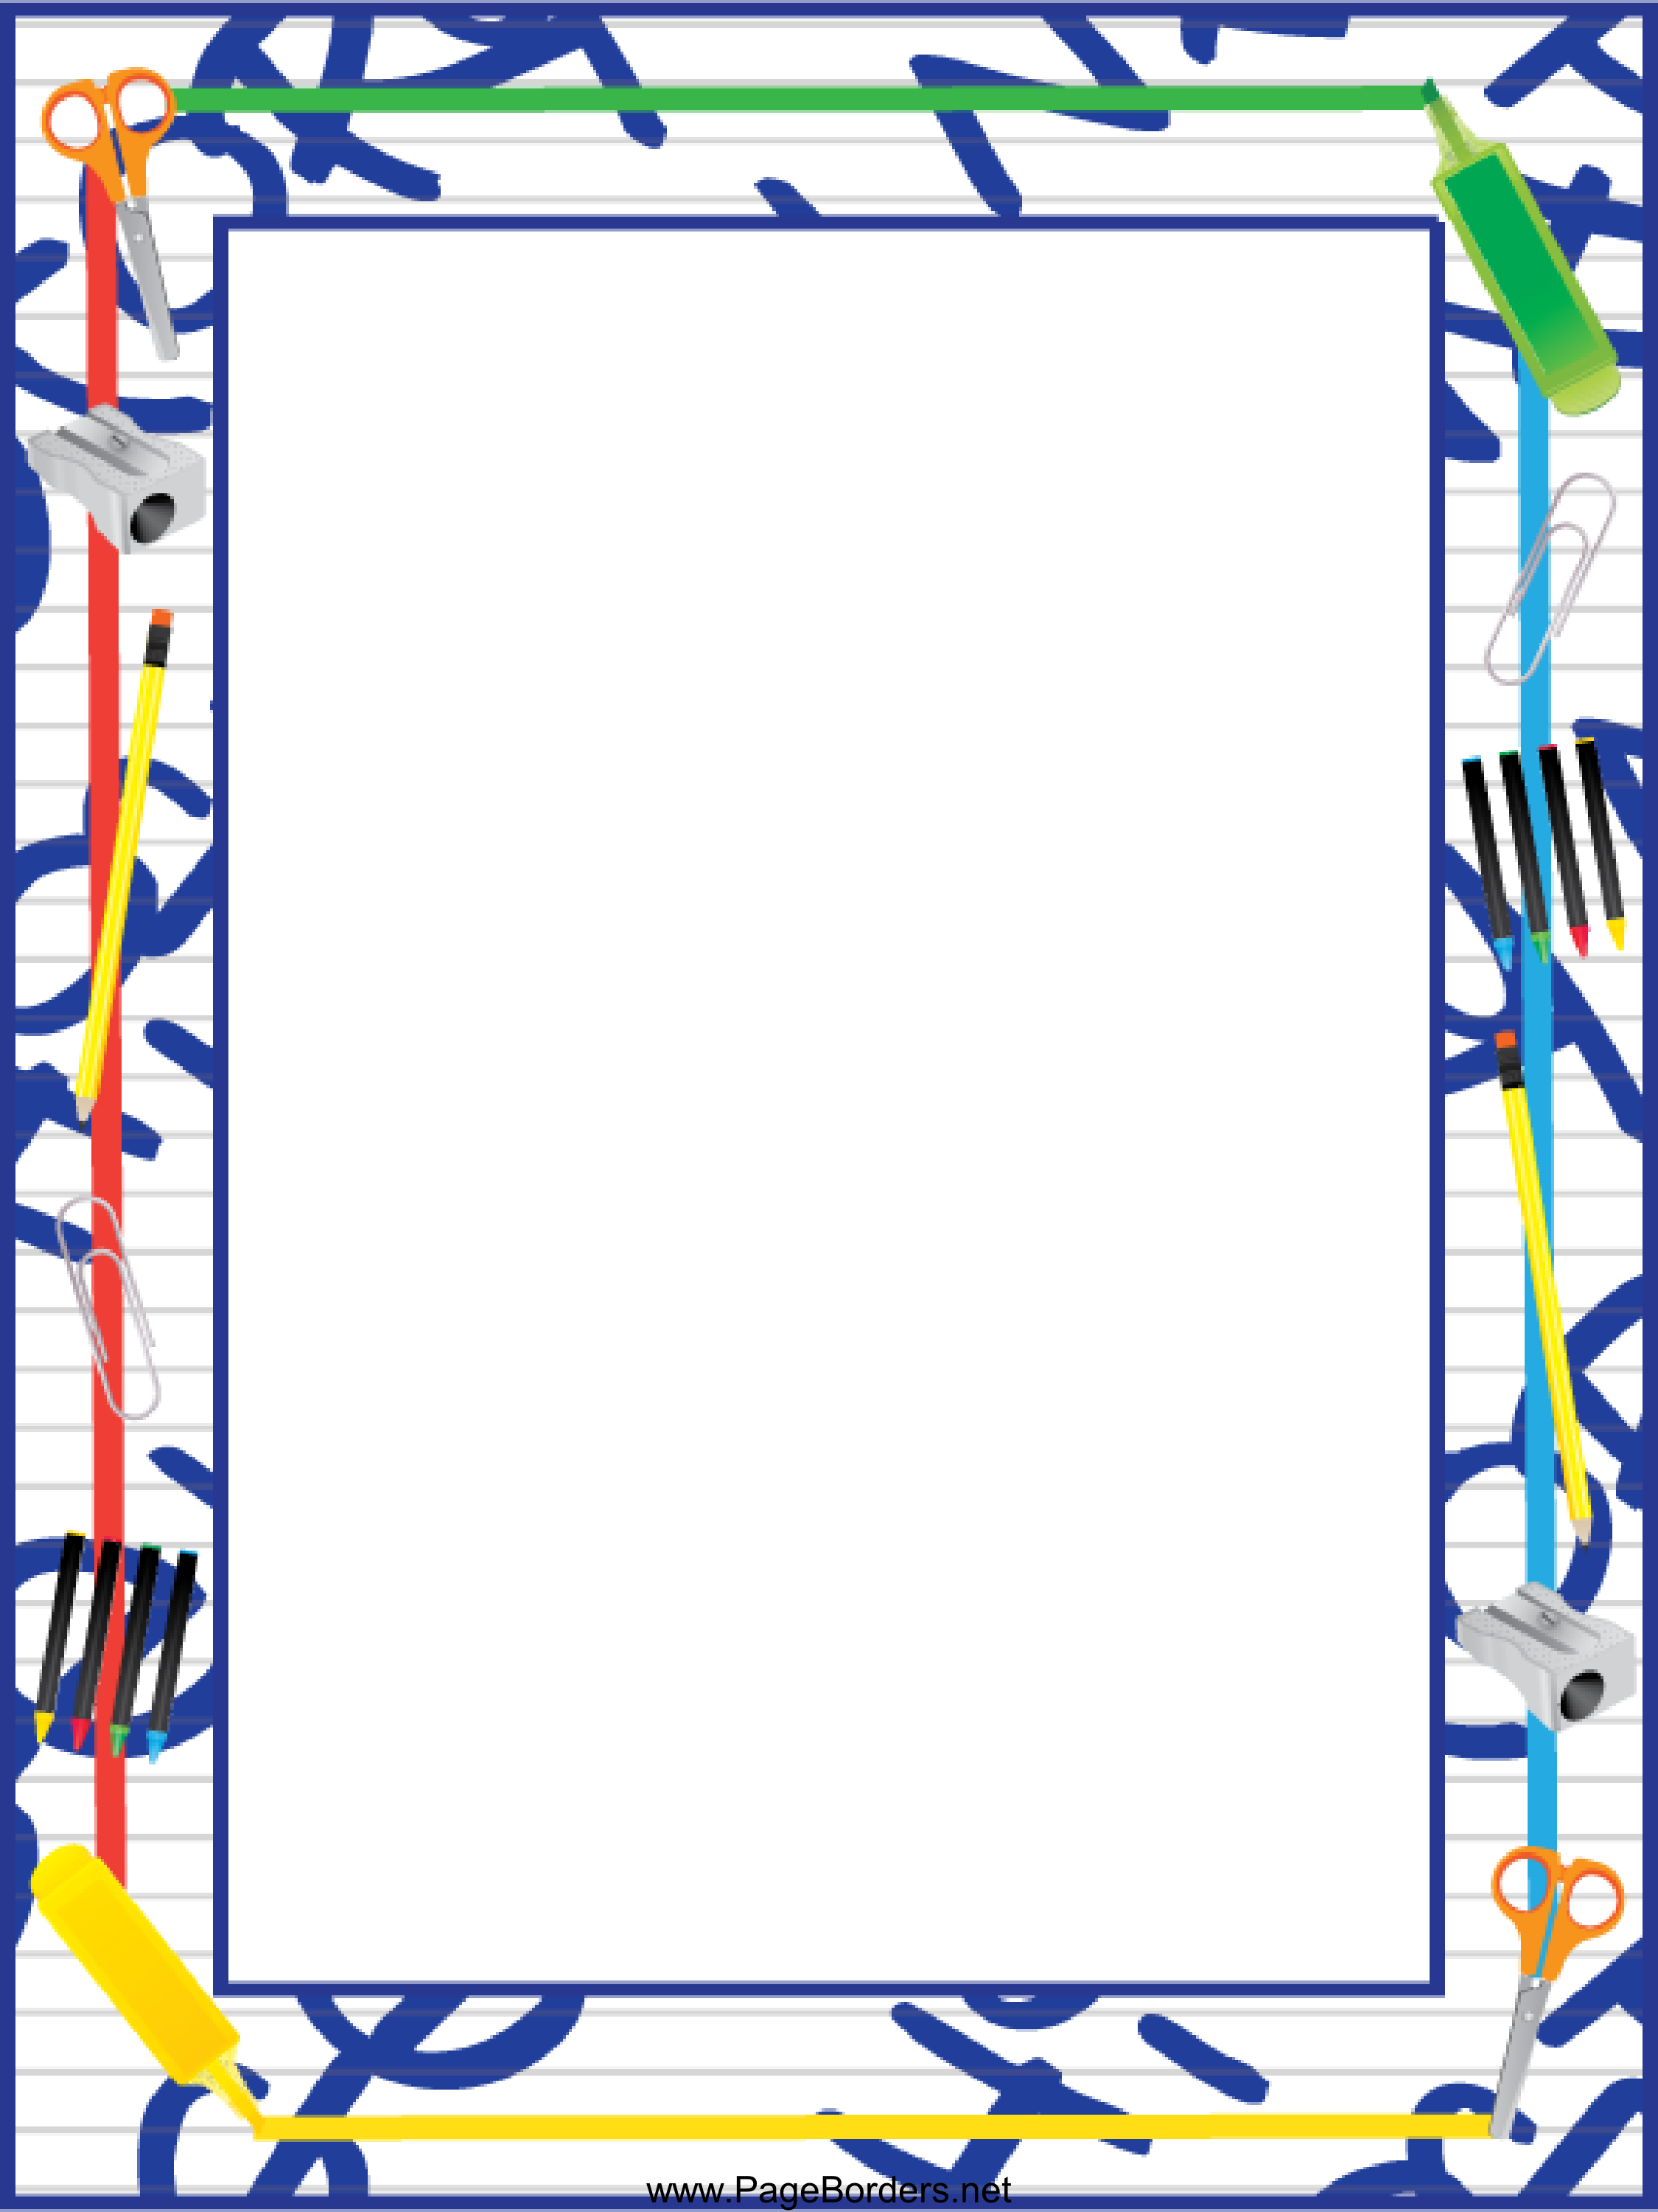

**Mrs. Smiley and Miss Brannon’s Classroom News**

**4/15/19-4/19/2019**

Thank you for all of the goodies and cards this week!



Important Dates:

4/24-Progress Notes go home

Unit 9 Week 2

Weekly Theme: What Do Good Citizens Do?

Wonders:

Letter Sounds

Blending

Segmenting

Substituting and Deleting Sounds

Sight Words- Play, Has

Morning Workstations:

* Long I Words
* Cause and Effect
* Writing- Using Wh questions to create stories
* Responsible Vs. Irresponsible Choices
* Leveled Readers
* Your Turn book

Math Concept: Naming and Describing 3D Shapes

Social Studies- Good Citizens

Science- Plants

Afternoon Centers:

* Scholastic Magazine
* 3 D shape coloring activity

Have a nice weekend! ☺