**VIDEO GAME AND EQUIPMENT GUIDELINES**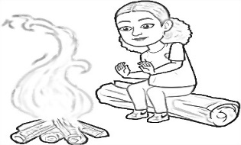

**Because we allow our campers to bring personal gaming devices and games to camp, we must adhere to the following guidelines. Violation of these guidelines will result in suspension of or termination of gaming privileges.**

*All personal video games must be rated E for everyone. No exceptions.

*No borrowing or trading of personal video games.

*There will be certain times when campers can use devices. They are not allowed to carry devices all day.

*Hawks Rise Summer Camp will not be responsible for lost, stolen or damaged video games and equipment.

(Gaming devices): ___________________________________________________

Child(ren) name: ____________________________________________________

Parent/Guardian Signature: _______________________________________

Date: _______________