**2021-2022**

Must have your own calculator (& must be this exact one please!)

**COURSE TOPICS**

* Real Numbers, Exponents, and Scientific Notation
* Proportional and Non-proportional Relationships and Functions
* Solving Equations and Systems of Equations
* Transformational Geometry
* Measurement Geometry
* Statistics

Mr. Angry

8th Grade Pre-Algebra Syllabus

**IMPORTANT INFO**

**Email:** [angryb@leonschools.net](mailto:angryb@leonschools.net)

**Website:** [www.leonschools.net/Domain/6739](http://www.leonschools.net/Domain/6739)

**Textbook:** online access through Classlink

**Canvas:** please be sure to stay up to date with our class Canvas page for assignments & updates

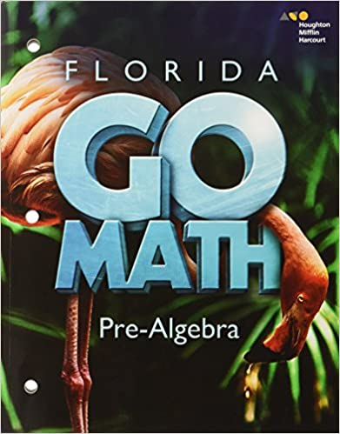  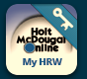

**Remind:** please see below for class codes

* A period - angrybp1
* B period - angrybp2
* C period - angrybp3
* D period - angrybp4
* E period - angrybp5
* F period - angrybp6

Academic Grades:

Assessments: 50%

Quizzes: 25%

Assignments: 25%

Grading Scale:

A = 90% - 100%

B = 80% - 89%

C = 70% - 79%

D = 60% - 69%

F = 0% - 59%

**ACADEMICS**

Assignments will be given in class daily and are due for a grade the following day.

It is the responsibility of the student to get missed assignments when absent. Please make an effort to be in attendance and on time every day! If you are absent, please refer to our 8th grade math (Pre-Algebra) Canvas page for make-up work. You may also wish to email me that morning.

All work is due on time. No unexcused late work will be accepted.

**LEARNING EXPECTATIONS**

Math is a subject that is learned through practice; therefore, daily assignments are required and students are expected to attempt every problem. In order to evaluate the student’s level of understanding, and correct errors, all steps must be shown when possible, including mental calculations. Students are responsible for seeking extra help as needed.

**CLASSWORK PROCEDURES**

• Use pencil!

• Write your full name (first and last!), period, date, and assignment number in the top right corner of the paper.

• Show all work neatly, number each problem, and circle or highlight the answer.

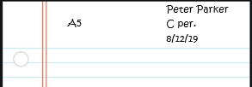

**WISH LIST SUPPLIES**

• Clorox wipes

• hand sanitizer

• Tissues

• Paper towels

• Notebook paper

• Pencils

**CLASS SUPPLIES**

• 3-ring binder

• Composition or spiral

notebook

• TI-30Xa calculator

• Pencils

• Loose-leaf notebook paper

•Headphones (for Computer) •Small expo makers (for mini whiteboards)