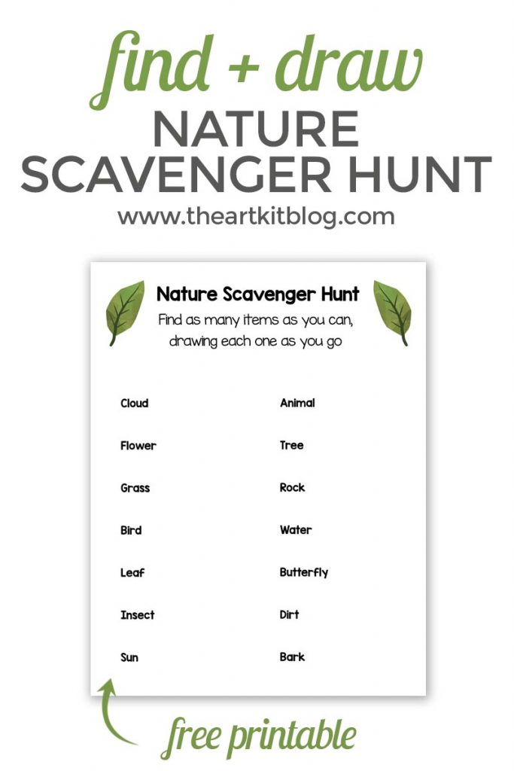

**Do drawings on another sheet of paper for more room.**