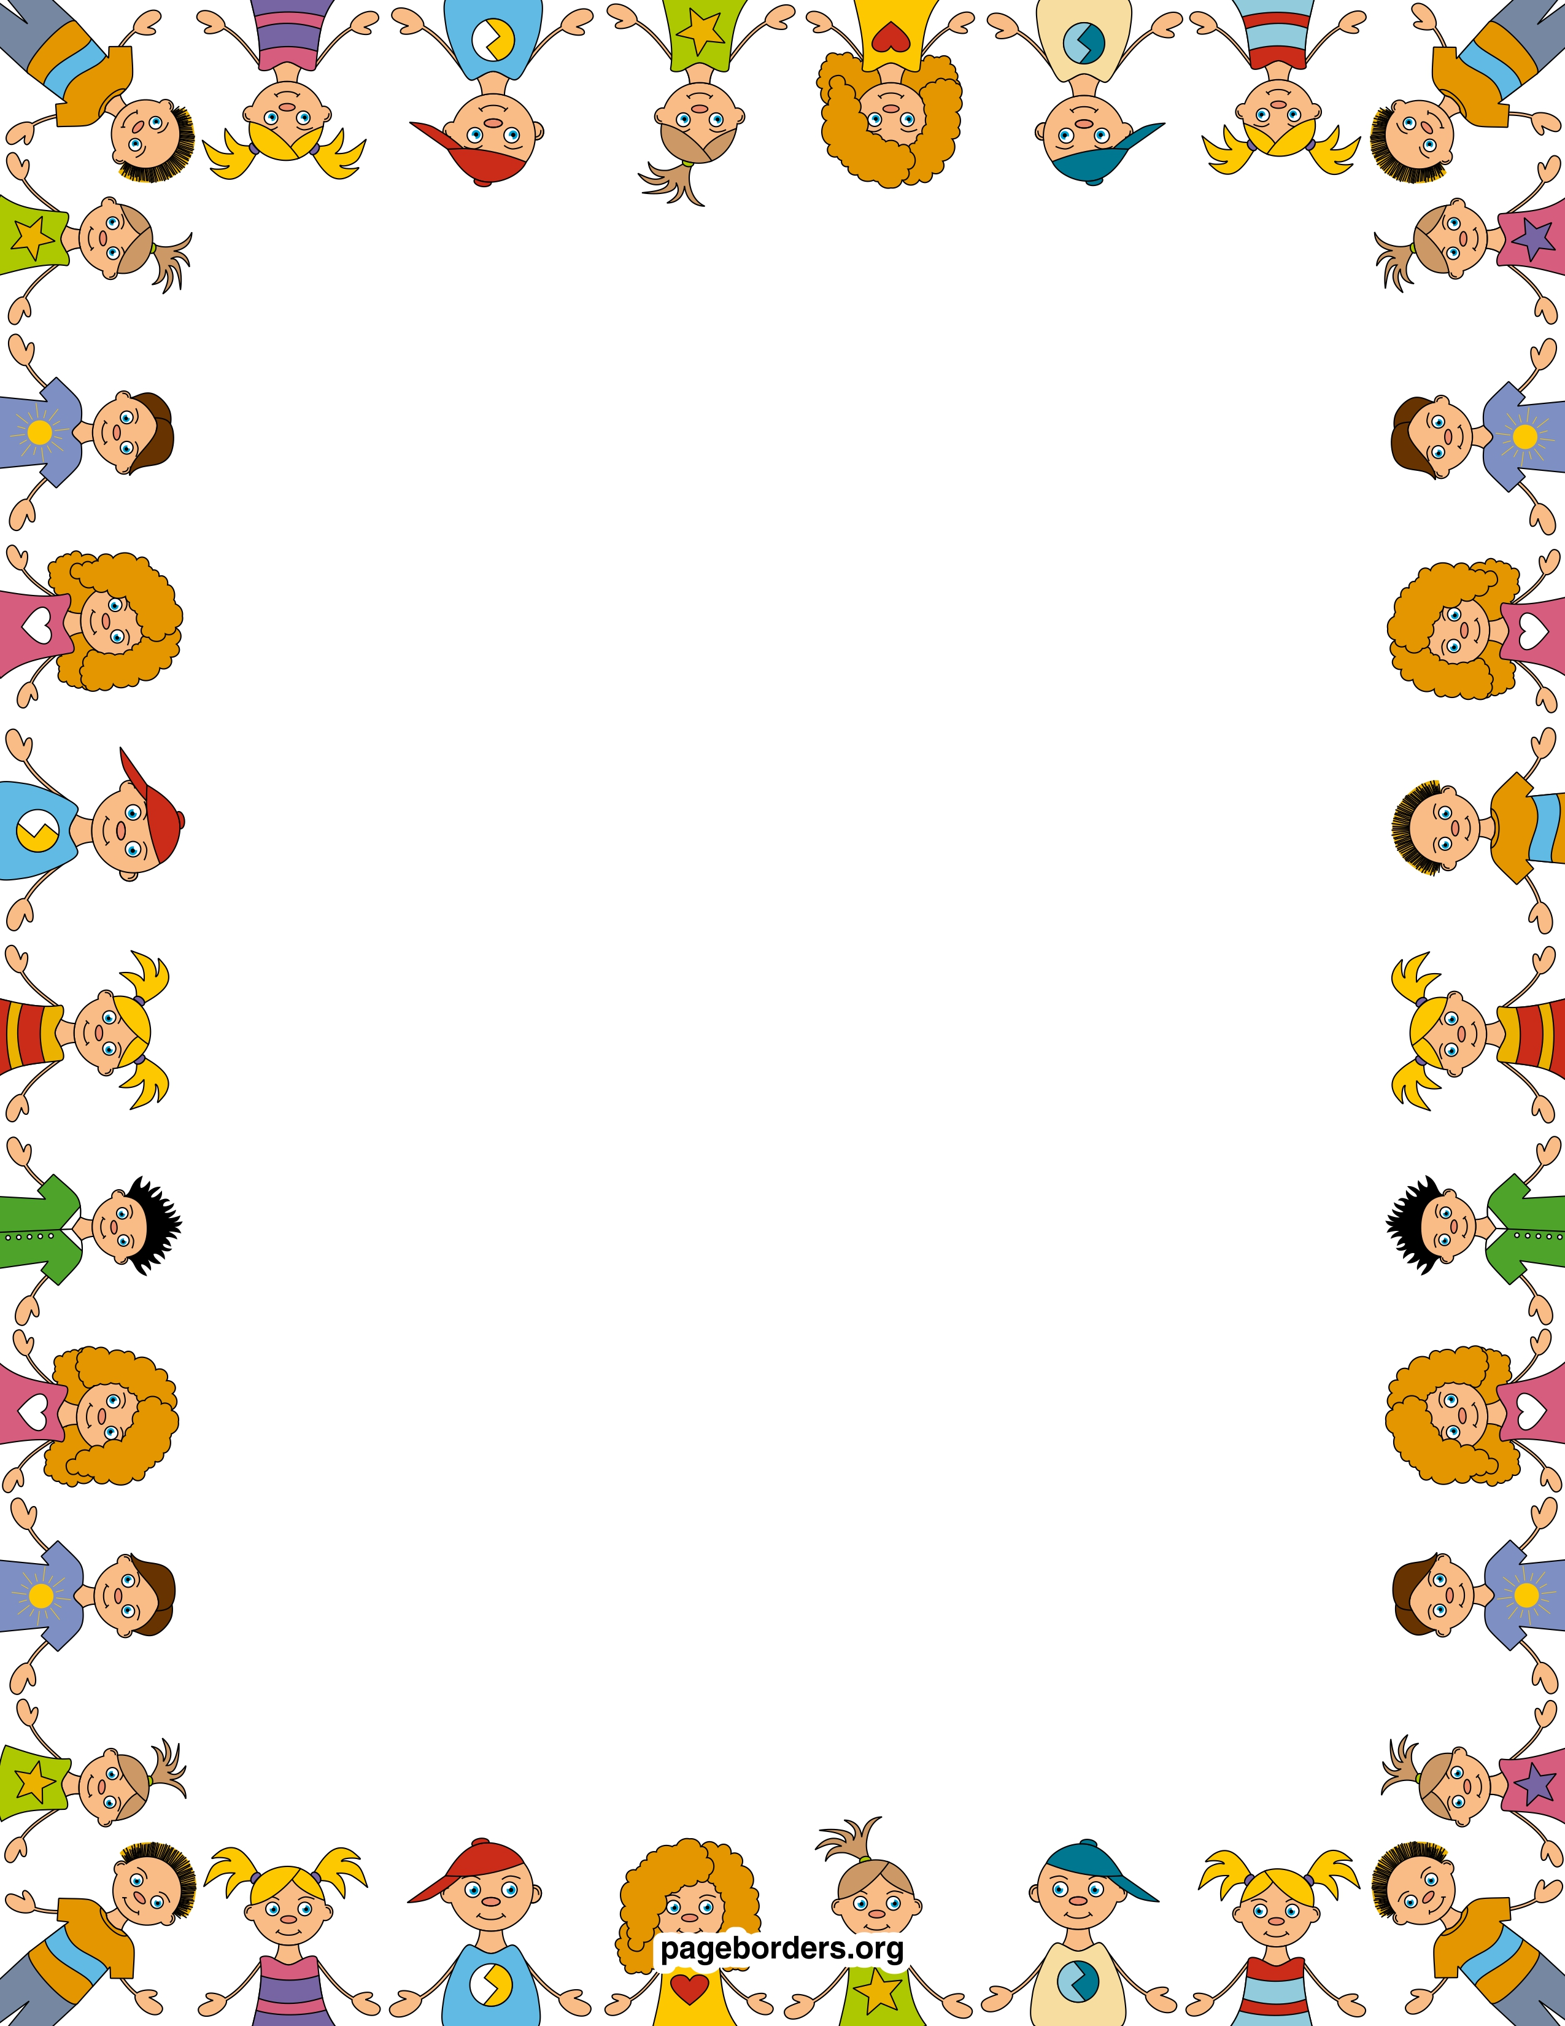

**Week Topic:**

Sort It Out

**Essential Question:**

In What Ways Are Things Alike and Different?

**Morning Centers:**

Poetry

Animal Sort

Pests Story

Long e words

Writing Thank You Notes

Leveled Readers

Journals

**Afternoon Centers**

Scholastic magazine

Poetry book

**Science**

Butterflies Lifecycle

**Important Dates:**

Important Dates:

5/3 First Friday

5/6 Last Day for sight words and reading packets homework

5/22 All Media Center books are due

5/27 Memorial Day- No School

5/29 Water Day- Early Release Day

5/30 Fun Fitness- Early Release Day

5/31 Last Day of School- Early Release Day

*On Early Release Days, school ends at 12:20

**Wonders**

Sight words: come, does

Long E

Listening for long E

Reading E words

Pronouns

Fiction genre

Writing Thank you notes

**Math**

Chapter 12- Classifying & Sorting Data

**Mrs. Smiley’s News**

**May 10, 2019**