**Ch. 13 Urban Patterns**

**Key Issue 3 Why Do Urban Areas Expand?**

**Rubenstein, p.478-487**

**I. ORIGIN AND GROWTH OF SUBURBS**

1. Define **suburb** and identify population distribution trends as they apply to suburbs. If you feel you need to, note the benefits associated with living in a suburb.
2. Define **annexation** and note trends/changes.
3. Due to the trend mentioned in #2, in the U.S., local government is extremely __________________.

What does this mean regarding services? Other issues?

1. What are consolidations and federations? What has prompted these?
2. Define **smart growth** and give some examples.

**II. SUBURBAN SPRAWL**

1. Describe **sprawl**. (Make sure to understand how it differs from other suburban growth.)
2. 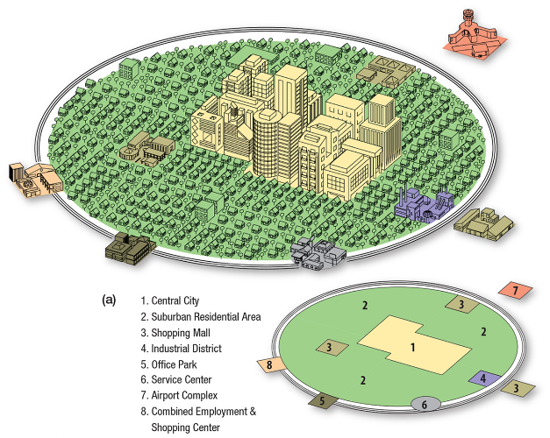Describe Chauncey Harris’ **peripheral model**.
3. How does population change as one moves away from the

city center?

1. Define **density gradient** and identify recent trends/changes.
2. What are some of the costs of urban sprawl?
3. a. Define **megalopolis** and identify some examples.

b. Within a megalopolis, cities are distinct, but…

**III. SUBURBAN SEGREGATION**

12. Identify the two types of segregation common in suburbs.

13. Contrast U.S. and U.K. suburbs.

*The U.K. model of suburb development is called **leapfrog development**. (See Figure 13-48b.)

14. Identify some ways social segregation is enforced.

15. Define **zoning ordinance:**

16. In what ways has the increase in suburbs impacted consumer services?

17. In what ways has the increase in suburbs impacted consumer services?

**IV. LEGACY OF PUBLIC TRANSPORT**

18. Identify public transit/commuting trends in the U.S.

19. How did 20th century transportation changes affect suburb growth?

20. What are challenges of and resulting from U.S. public transit?

21. Describe public transit in European countries. Why the difference?

**V. RELIANCE ON MOTOR VEHICLES**

22. Identify (more) American commuting trends.

23. Identify John Borchert’s five epochs, both the primary mode of transportation, and the resulting

settlement trends.

24. Rubenstein states that one benefit of individual vehicle use is *perceived* [lower] cost compared to

the cost of public transit. It what ways is this a “perceived” benefit?

25. What are some costs of individual vehicle use?