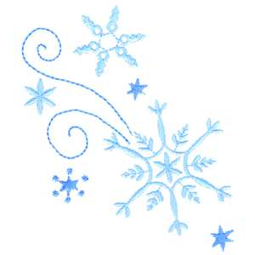

Kindergarten

Connection

January 2025

**Language Arts-Saavas:**

**Grammar:** Pronouns, Syllables

**Writing:** Sentence structure

**Themes:** “Tell Me a Story” (unit 3), “Then and Now” (Unit 4)

**Language Arts-UFLI:**

**Letters/Sounds:** y, w, j, x (ks), qu (kw), v, z

**New High Frequency Words:** was, you, what, have

Themes:

**New Year’s Day**

**Martin Luther King Jr. Day**

**100th Day**

Important Dates:

January 10: First Friday- Wear Nest Shirt

January 15: Report Cards Published in Focus

January 20: MLK Jr. Day-No School

January 24: Spirit Sprint Kick-Off

January 30: 100th Day of School

January 31: Spirit Sprint

**Go Math:**

### Chapter 8: Count, Represent, and Compare Numbers Through 20

### Chapter 9: Put Together and Take Apart Numbers Through 5

### Chapter 10: Put Together and Take Apart Numbers Through 10

**Science:**

Unit 7: Force & Motion / Unit 4: Day and Night

**Social Studies:**

New Year’s- Goal Setting/Resolutions

Martin Luther King Jr.-Kindness, Inclusion, Cooperation

Please update your child’s extra set of clothes that is kept at school!

Thank you for you support.

We appreciate you!

**The Kindergarten Team**

Mrs. Campbell, Mrs. Deason, Mrs. Lindsey, Mrs. Ramos, Ms. Randall, Mrs. Rockwood, Ms. Lindquist, Ms. Hammond