Individual Action Plan (IAP)

The Individual Action Plan (IAP) will help plan for a successful first year and monitor the beginning teacher’s progress in completing the VOC Program requirements. The School Support Team, which consists of the beginning teacher, mentor, and an administrator, will meet to develop each page of the Individual Action Plan. The initial Individual Action Plan (IAP #1) will be completed within the first three weeks of the beginning teacher being enrolled in the program and after meeting with their mentor. In addition to the IAP #1, the beginning teacher, mentor, and an administrator will meet three additional times to monitor the beginning teacher’s progress, and will document these meetings using IAP #2, IAP #3, and IAP #4. Please be sure to schedule meeting times where all three stakeholders can attend.

The IAP will be used to note strengths and areas of concern. As needed, training and support will be planned by the school support team and coordinated and monitored by the mentor. The beginning teacher, the mentor, and an administrator should be fully involved in developing and modifying the IAP. There should be at least four entries on the IAP, (initial, before/after first mentor observation, before/after second mentor observation, and end of the year)

- Entry 1: Initial Planning Sessions (IAP #1)
- Entry 2: First Mentor Observation (Planning and Follow-up) (IAP #2)
- Entry 3: Second Mentor Observation (Planning and Follow-up (IAP #3)
- Entry 4: Final Review Session (IAP#4)

The beginning teacher, mentor, and an administrator must sign each page of the IAP.

School Support Team

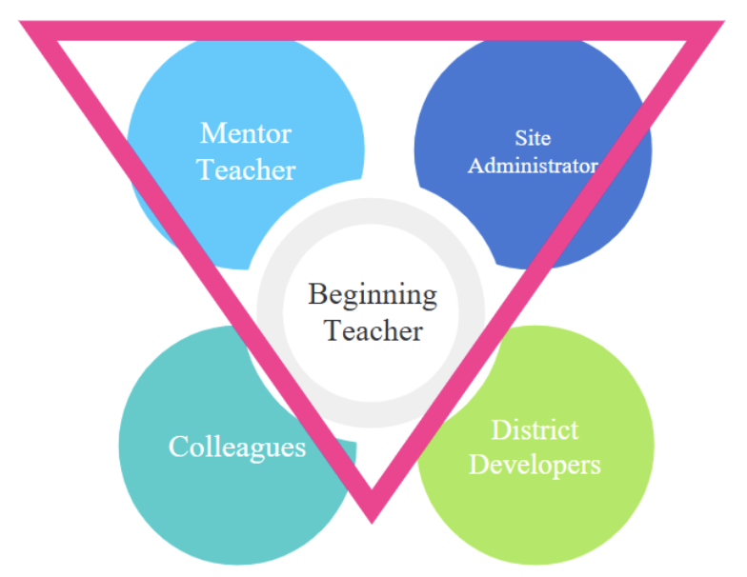

Your colleagues and district support, including professional learning opportunities, are available to ensure you are successful this year and beyond.

INDIVIDUAL ACTION PLAN
(IAP #1)
Beginning Teacher___________________________________________________________________
(Please Print First and Last Name)

Initial Planning Session
(Complete with the mentor and administrator within three weeks of the Beginning Teacher Program Orientation.)

Date: _____________

Meet with your mentor to plan for the school year. Read and review the PEC Completion Guide, Information You Should Know packet, Florida Educator Accomplished Practices, the Florida Standards for the grade and/or subjects you are teaching, and your Statement of Eligibility.
Date scheduled for first mentor observation. Date: _____________
Date scheduled for first formal observation with administrator. Date: _____________
Discuss your perceived strengths and areas of concern and how you will get the support and training that you need.

Perceived Strengths:

Perceived Areas of Concern:

How will concerns be addressed? List specific meetings/workshops/training sessions planned (for example: Preparation for classroom observation, one-on-one training with mentor or team member, observing other classrooms, demonstration lesson by mentor or other teacher, district or site-based workshop/PLC.)

Required training currently enrolled in or completed:

_____ Proactive Classroom Management and Building Relationships (Register in LEADS, Completed In-person)
_____ Your First Year in CTE: 10 More Things to Know Expert Session (See Online Seminar Document)
_____ From Company to Classroom: Engaging STEM Professional Talent (See Online Seminar Document)
_____ Using Action Based Research Webinar — Michael T. Holik, Ed.D. (See Online Seminar Document)

Signatures: Vocational Participant __________________________________________________________

Mentor ____________________________________ Administrator ________________________________

INDIVIDUAL ACTION PLAN
(IAP #2)

Beginning Teacher___________________________________________________________________
(Please Print First and Last Name)

First Mentor Observation (Planning and Follow-up)
(Complete mentor observation prior to the administrator’s first formal observation. Follow-up must occur within 10 days of mentor observation.)

Date: _________

Mentor observation scheduled/completed ___________________________________ (dates)

Administrator’s formal observation scheduled/completed __________________________ (dates)

Meet with your mentor to discuss areas of concern and what she/he will be looking for in your first observation. Discuss which FEAPs you should be demonstrating, and how you can demonstrate mastery of those FEAPs.

Which FEAPS will be demonstrated in this lesson?

How will you demonstrate mastery of those FEAPs?

How will areas of concern be addressed? List meetings/workshops/training sessions planned (for example: one-on-one training with mentor or team member, observing other classrooms, demonstration lesson by mentor or other teacher, district or site based workshop/PLC.)

Required training currently enrolled in or completed:

_____ Proactive Classroom Management and Building Relationships (Register in LEADS, Completed In-person)
_____ Your First Year in CTE: 10 More Things to Know Expert Session (See Online Seminar Document)
_____ From Company to Classroom: Engaging STEM Professional Talent (See Online Seminar Document)
_____ Using Action Based Research Webinar — Michael T. Holik, Ed.D. (See Online Seminar Document)

Signatures: Vocational Participant __________________________________________________________

Mentor ____________________________________ Administrator ________________________________

INDIVIDUAL ACTION PLAN
(IAP #3)
Beginning Teacher___________________________________________________________________
(Please Print First and Last Name)

Second Mentor Observation (Planning and Follow-up)
(Complete mentor observation prior to the administrator’s second formal observation. Follow-up must occur within 10 days of mentor observation.)

Date: _________

How is the year going?

Mentor observation scheduled/completed ____________________________________ (dates)

Administrator’s formal observation scheduled/completed __________________________ (dates)

Meet with your mentor to discuss your areas of concern on your first observation, and what she/he will be looking for in this observation. Discuss which FEAPs you should be demonstrating, and how you can demonstrate mastery of those FEAPs.

Which FEAPS will be demonstrated in this lesson?

How will you demonstrate mastery of those FEAPs?

How will areas of concern be addressed? List meetings/workshops/training sessions planned (for example: one-on-one training with mentor or team member, observing other classrooms, demonstration lesson by mentor or other teacher, district or site based workshop/PLC.)

Required training currently enrolled in or completed:

_____ Proactive Classroom Management and Building Relationships (Register in LEADS, Completed In-person)
_____ Your First Year in CTE: 10 More Things to Know Expert Session (See Online Seminar Document)
_____ From Company to Classroom: Engaging STEM Professional Talent (See Online Seminar Document)
_____ Using Action Based Research Webinar — Michael T. Holik, Ed.D. (See Online Seminar Document)

Signatures: Vocational Participant __________________________________________________________

Mentor ____________________________________ Administrator ________________________________
INDIVIDUAL ACTION PLAN
(IAP #4)
Beginning Teacher___________________________________________________________________
(Please Print First and Last Name)

Final Review Session
(Complete no later than one week before program due date.)

Date: _________

How did your first year of teaching go?

What are your strengths?

What are your areas of concern?

Mentor’s and Administrator’s recommendations for addressing these concerns:

Have you completed all required training?

_____ Proactive Classroom Management and Building Relationships (Register in LEADS, Completed In-person)
_____ Your First Year in CTE: 10 More Things to Know Expert Session (See Online Seminar Document)
_____ From Company to Classroom: Engaging STEM Professional Talent (See Online Seminar Document)
_____ Using Action Based Research Webinar — Michael T. Holik, Ed.D. (See Online Seminar Document)

Signatures: Vocational Participant __________________________________________________________

Mentor ____________________________________ Administrator ________________________________

