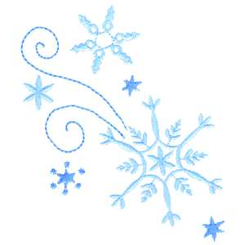

Kindergarten

Connection

January 2024

**Language Arts-Saavas:**

**Grammar:** Pronouns, Syllables

**Writing:** Sentence structure

**Themes:** “Tell Me a Story” (unit 3), “Then and Now” (Unit 4)

**Language Arts-UFLI:**

**Letters/Sounds:** r, l, w, j, y, x (ks), qu (kw)

**New High Frequency Words:** from, look, book, are, was, you

Themes:

**New Year’s Day**

**Martin Luther King Jr. day**

**100th Day**

Important Dates:

January 12: First Friday- Wear Nest Shirt

January 15: NO SCHOOL – MLK, Jr. Day

January 17: Report Cards Published in Focus

January 31: 100th Day of School

Go Math:

Chapter 7: Count, Represent and Compare Numbers Through 15

### Chapter 8: Count, Represent, and Compare Numbers Through 20

Science:

Unit 7: Force & Motion / Unit 4: Day and Night

Social Studies:

New Years- goal setting/resolutions

Martin Luther King Jr.-kindness, inclusion

Please update your child’s extra set of clothes that is kept at school!

Thank you for you support.

We appreciate you!

**The Kindergarten Team**

Mrs. Campbell, Mrs. Deason, Mrs. Lindsey, Mrs. Manuel, Mrs. Ramos, Ms. Randall,

Ms. Rwito, Ms. Lindquist, Ms. Hammond