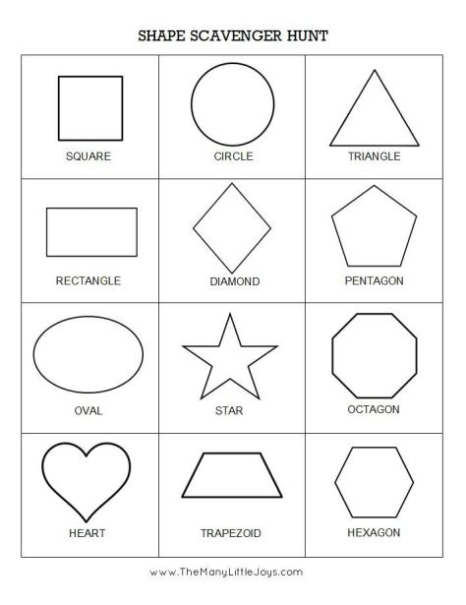

TAKE PAPER WITH YOU AND DRAW THE ITEM YOU SAW WITH EACH SHAPE.