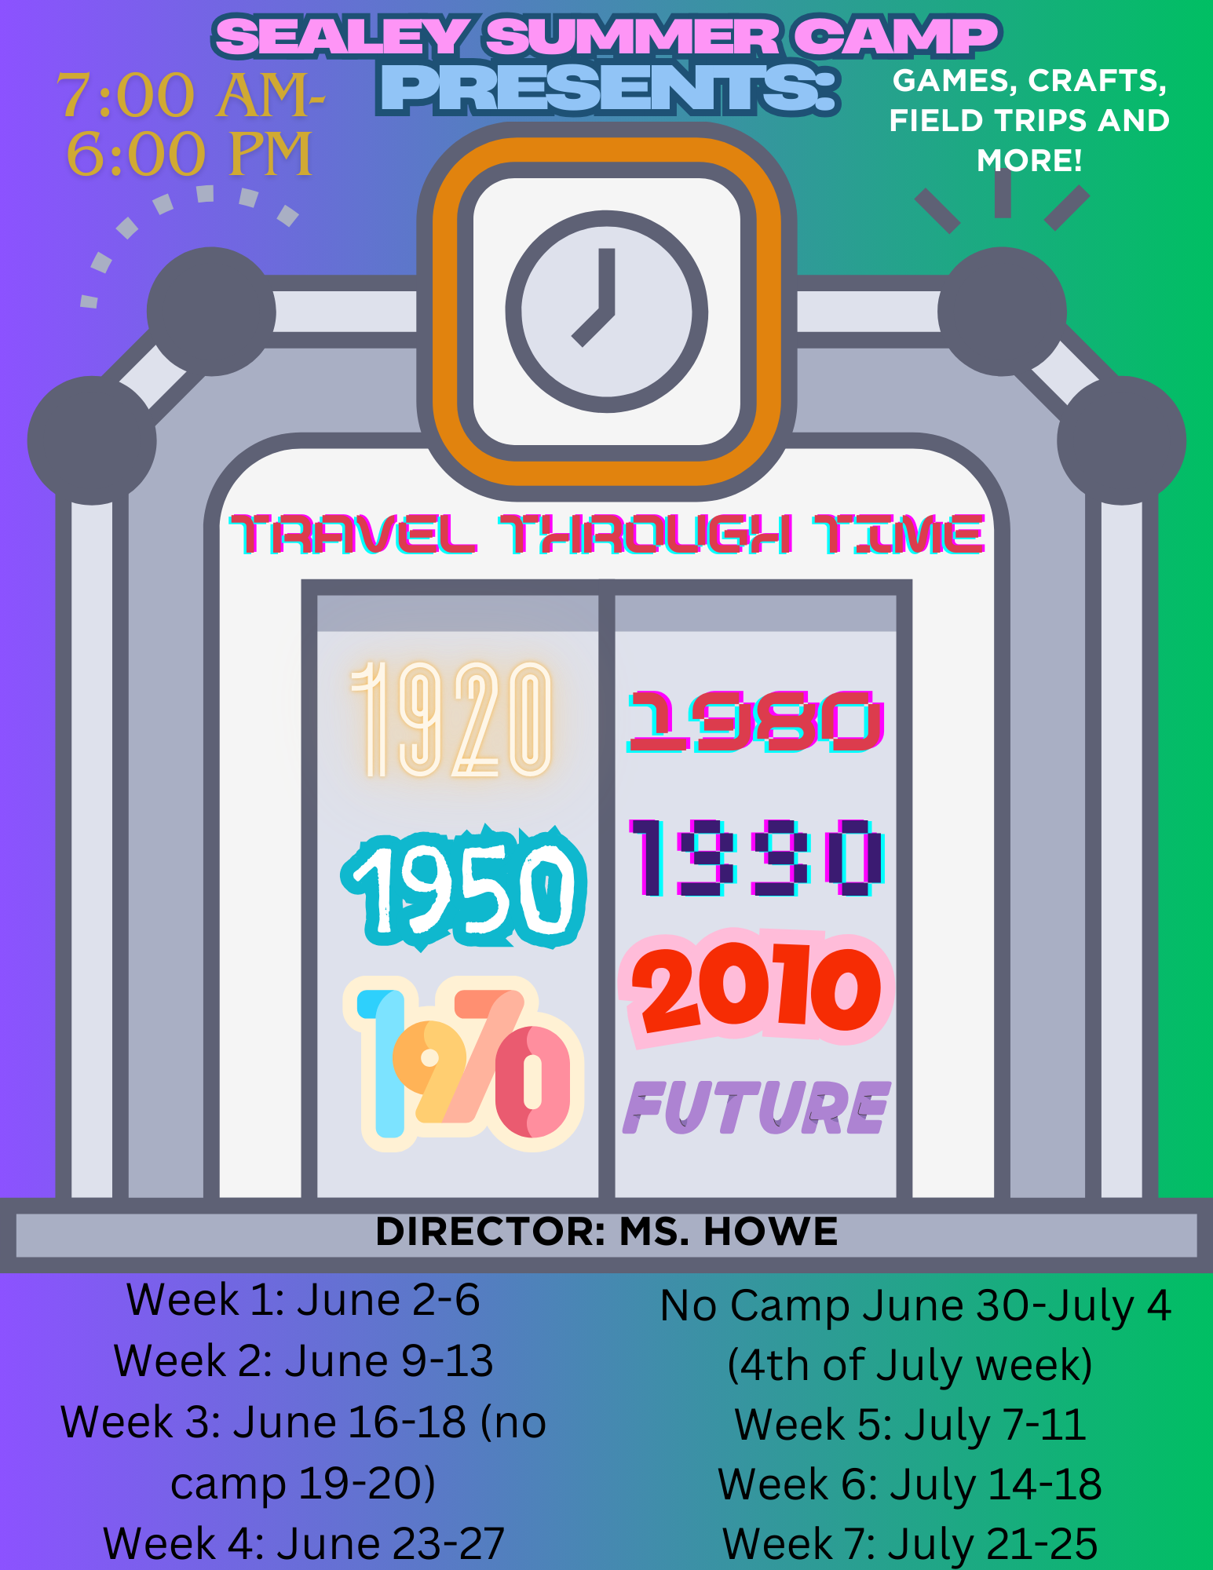



**Eligibility and Enrollment:** Summer camp participants must be rising kindergartners **(must be 5)** through rising sixth graders and meet the basic entry-level criteria in the areas of self-care, communication, mobility, and social-emotional development and be potty-trained. All participants must complete the Sealey Summer Camp registration form prior to program participation. Your child will only have a reserved slot when we have received all registration forms and $60.00 registration fee per child. If you need to cancel your child’s attendance on any given week, please alert Ms. Howe, Director as soon as possible. Please only sign up for weeks you are **needing**. The last day to cancel on registered weeks without a penalty is Wednesday, May 28, 2025. Please see cancellation information on the following page.

***If your child misses a day, you are still responsible for the weekly payment.***

**Camp Hours:** Summer Camp will run for seven weeks, from June 2, 2025- July 25, 2025. We will be closed June 19, 2025 and June 20, 2025 in observance of Juneteenth. We will be close the week of June 30, 2025 – July 4, 2025, for the 4th of July. Camp will reopen Monday, July 7, 2025. **Our last day of camp is July 25, 2025**.

Hours of operation are 7:00 a.m.-6:00 p.m. daily, unless otherwise stated. Please be sure to review ClassDojo and the whiteboard for important detailed information. There is late fee of $1.00 per minute charged for late pick-ups after 6:00 p.m. This is a Leon County School policy and is nonnegotiable. All payments must be made in the form of check, money order or online payment. See the payment page for details.

**Drop-off and Pick-up:** **Drop-off ends at 8:00am daily unless otherwise stated.** For the safety and well-being of our students, each child must be signed in & out by a parent or guardian daily. No child will be released to a person not authorized in writing by a custodial parent. Parents/guardians must sign their child out in the presence of EDEP staff. An adult must escort the student(s) into the designated drop off area each day and sign them in. When picking up a student, an authorized adult 18 years or older will need to come to the same designated drop off area unless otherwise stated. Please remember to email us or send a message via ClassDojo if someone other than you or a designated person is picking up your child. We will verify their name by an ID. Your student will not be released to any individual without their identification. **If you need to pick up your child while we are on a field trip, please notify the Director during check-in the morning of.**

**Emergency Pickup:** If someone other than a designated person on the enrollment application comes to pick up your child, prior notification in writing via letter, email or message on ClassDojo must be provided to the EDEP Director. Once the message has been sent, please notify us by phone to check the receipt of the message. A picture ID will be required for verification at the time of pickup. Emergency e-mail notification may be sent to [howek@leonschools.net](mailto:howek@leonschools.net).

**Camp Shirt:** Campers will receive one 2025 Sealey “Travel Through Time” Summer Camp shirt. These items must be signed off on, for proof of receipt. After each child receives their camp shirts, extra shirts will be available for $10 via check or money order. The weeks we are scheduled to visit Skate World, students must have socks on.

**Dress Code:** Students must wear **closed toed shoes,** they may bring flip flops for pool days and they may bring water shoes/crocs on water days. No spaghetti straps, strapless tops, or crop tops. Students MUST wear socks on days we go to Skate World, no socks = no skating. Camp shirts MUST be worn during field trips, all field trip days are listed on the calendar. We will have dress up days every day this summer, you will find them listed on the Summer Camp Dress Up Days Calendar.

**Discipline:** To achieve the goal of providing a quality program for your child(ren), in an environment of cooperation and respect, all members of the Sealey Summer Camp staff utilize positive discipline practices. The policies and practices are consistent and conform to Sealey’s discipline policy. If these discipline practices do not facilitate the appropriate behavior, parents will be notified and then a consequence suitable to the disciplinary offense will occur. The consequences may be, but are not limited to sitting out for activities, or not being allowed to attend camp for a number of days. If a student continues to choose to demonstrate inappropriate behaviors within the program, their behavior will be interpreted to mean that the student does not have the desire to participate in the program. At such time, the student will be dismissed from the program at the discretion of the Summer Program Director. Students may be asked to get picked up early or may not attend camp if there is a refusal to follow directions. Students may not be able to attend field trips without a chaperone if they have shown they need more assistance/supervision due to conduct. If a chaperone cannot accompany the student, they cannot attend the trip. Should it be deemed that the participant chooses not to behave in an appropriate manner, then the student will be dismissed from the program for the remainder of the summer and no refund will be given. This is non-negotiable. All consequences are at the discretion of the Director.

**Attendance:** If your child is going to be absent or picked up by someone other than you, please notify our office staff immediately at 850.488.5640, e-mail Ms. Howe or send a message via ClassDojo. ***We cannot refund or credit your account due to attendance.***

**Daily/Weekly Updates:** Program updates will be provided every Monday morning at check-ins. Program updates will be available on ClassDojo. Please note any changes to events and special attire, etc. We will always alert you of any changes to our schedule.

**Illness:** If your child appears sick or should become sick while participating in Summer Camp, they will be sent to our designated area for assessment. A parent or guardian will be contacted and must pick their student up immediately. Your student will not be able to return to camp until they are feeling better and fever free for 72 hours.

**Lunch & Snack:** Morning snacks will be provided. Students will be responsible for their own lunch, unless otherwise stated. Afternoon snack will also be provided. Please be sure your child has a replacement meal or snack if you have a picky eater.

**Registration Fees:** The registration fee is a non-refundable fee of $60.00 per child. Registration will have to be paid by either check or money order. This is required at the time of registration. We must receive both the registration forms and fee together. They will not be accepted separately. No discounts can be applied to the fee. The registration fee secures a spot for your child, allows us to begin processing your paperwork and will cover the cost of your child’s camp shirt. Please only sign up for the weeks you intend your camper to participate in. **Your registration fee will be forfeited if you cancel/or your child doesn’t show up during any of the weeks you registered for after the registration deadline**. To return, you will need to **re-register**, and submit another $60.00 payment.

**Medication:** Whenever a child is to be given prescription or over-the-counter medicine during camp, the parents must provide a *Medication Authorization Form.* All medications must be provided in the original container, labeled with the student's name, name of the medication, and the time and exact dosage to be given. Please allow enough time to do a pill count with the Director to confirm the number of pills issued. When your student has taken all the medication, the empty bottle must be picked up from our office for a new dosage (if needed). Please do not send your sick child to camp. Make sure to call the Camp Office to notify the Director. For more details on the use of medication. Visit the LCS web page on bylaws for medication details.

**OPEN DOOR POLICY:** Parents are granted access, in person and by phone to their child care facility during normal business hours of operation and anytime the child is in care. Since the pandemic we ask that you call our office to set an appointment first.

**Tuition:** Tuition is charged by the week. Payments must be made in the form of a check, money orders, or credit card the **Monday prior to each week of camp**.

* Credit Card Payments: Sealey’s Summer Camp is unable to accept credit card payments in person. The online payment page is accessible through the FOCUS parent portal. If you do not already have access, please contact our school’s registrar for further information to set one up. If your child is not yet enrolled in school or attends another school, the online payment option will not be available to you. Parents/guardians are responsible for paying for tuition prior to their camper(s) starting. We are not responsible for any technological errors or computer malfunctions. **In the event of computer issues/malfunctions with the website or payment, another form of payment must be made.**

Cash is not accepted as a form of payment, this is an LCSB policy. Please refer to our tuition chart for tuition costs. Payments must be received prior to a camper participating in camp. No exceptions.

Make all checks/money orders payable to Leon County Schools (LCS.) Please include your child(ren)’s first and last name and what your payment is intended for in the memo line. Receipts will be provided at the time of payment.

* **NO REFUNDS** No refunds are to be permitted, except for documented cases of prolonged illness (2 weeks or more) or family relocation. Absolutely no refunds will be given on registration fees. Refunds must be requested in writing.

**Late Payment Fee:** There is a $10.00 late fee if tuition is NOT paid by the due date. Parents/guardians are still required to pay if the child is out on Monday when tuition is due, regardless of illness/out of town. Payments are always welcome prior to the due date to prevent late fees.

* Registration will be canceled for payments not received by the late payment deadline. See payment calendar for payment dates.

**Returned Checks:** Returned checks are processed through the LCSB District Office. If your check is returned unpaid, the finance department will attempt to redeposit a second time. In the event your check is returned again, the district office will send it to the school’s EDEP manager for collection. You will be notified and a return check fee of $20 will be assessed, and services will be suspended until payment is made. If two checks are returned unpaid in a single school year, parents will be required to pay by money order for the remainder of the year.

**Late Pick Up:** Your child must be picked up by 6:00 pm at the LATEST. Otherwise, a late fee of **$1 per minute** will be assessed. Late fees are due when the child is picked up, and will be strictly enforced. If a child has not been picked up by 7:00pm, LCS Safety and Security office or the school’s resource officer will be contacted for assistance.

**Sibling Discounts/ Employee Discount:** There is a 10% discount for each additional sibling in the same household. This discount cannot be applied to other family members, i.e. cousins, etc.

Leon County School Employee discount can only be redeemed by Leon County School employees working for Leon County Schools during the 2025 Summer. Employment must be verified first. Employees must include a copy of their LCS ID at the time of registration. Employee discount ONLY applies for the LEGAL guardian to the child/children.

**Scholarship:** Project Care scholarships are not offered in the summer.

**Cancellation:** The last day to cancel registered weeks without a penalty is Wednesday May 28, 2025. Any cancellations made after that date will result in forfeiting your registration, and result in having to re-register your child to reserve any other week. This is non-negotiable.

**Insurance:** Leon County Schools and Sealey Elementary School/Summer Camp does not carry accident insurance on participants. It is the parent’s responsibility to carry adequate insurance. Such policies are available through Leon County Schools. If needed, please check the school’s secretary for an application or visit https://www.floridakidcare.org/

**Electronics:** Cell phones, Apple/Samsung (watches), iPads, or any other electronic devices are not allowed at camp.

***Sealey Elementary School/Summer Camp is not responsible for any lost, stolen or damaged devices.***

**Payment Policy Summary:**

* Students may not participate in camp until a payment is made in full each week.
* A late fee will be added to your account of $10.00 regardless of your child’s attendance in camp on the due date.
* A late fee must be included with payment for a student to return.
* Payments are to be hand delivered by an adult to a camp staff member. Sealey Elementary School’s Summer Camp will not be responsible for payments delivered in any other way.
* We only accept check, money order or credit card payments as a form of payments. Cash will not be accepted.
* There is a late pick-up fee of $1.00 per minute after 6:00 p.m. This payment is due at the time of pick up and cannot be paid in cash.
* Employee Discount: Must be **actively working** for Leon County Schools during the 2025 Summer. Employment must be verified first. Employees must include a copy of their LCS ID at the time of registration.
* Project Care Scholarship: Project Care Scholarships are not offered in the summer.
* The last day to cancel registered weeks without a penalty is Wednesday, May 28, 2025.

|  |  |  |  |  |  |  |  |
| --- | --- | --- | --- | --- | --- | --- | --- |
| 2025 Summer Payment Schedule | | | | | | | |
| **Weeks:** | **Dates:** | **Payment Due Date** | | **Late** | | **Registration Canceled for Non-Payment** | |
| Week 1 | June 2-6 | Tuesday | May 27 | Wednesday | May 28 | Thursday | May 29 |
| Week 2 | June 9-13 | Monday | June 2 | Tuesday | June 3 | Thursday | June 5 |
| Week 3- 3 day | June 16-18 | Monday | June 9 | Tuesday | June 10 | Thursday | June 12 |
| Week 4 | June 23-27 | Monday | June 16 | Tuesday | June 17 | Wednesday | June 18 |
| Week 5 | July 7-11 | Monday | June 30 | Tuesday | July 1 | Wednesday | July 2 |
| Week 6 | July 14-18 | Monday | July 7 | Tuesday | July 8 | Thursday | July 10 |
| Week 7 | July 21-25 | Monday | July 14 | Tuesday | July 15 | Thursday | July 17 |

**\*NO CAMP: June 19-20, June 30-July 4**

* Activity Fee $10- This is only for our on-site art classes, if you want your child to participate you may sign them up by adding the activity fee to your weekly payment.
  + AR Workshop Art class Week 1: fee due May 27 (grades k-5)
  + Tie-Dye Shirts Art class Week 3: fee due June 9 (grades k-5)
  + Rock Painting Art Class Week 4: fee due June 16 (grades k-5)
  + Animal Painting Art Class Week 5: fee due June 30 (grades k-5)
  + Disney Ear Headband Art Class Week 6: fee due July 7 (grades 2-5)
  + Nell’d It Art Class Week 7: fee due July 14 (grades 2-5)

**Tip:** Try setting a reminder of all tuition due dates, in your phone, planner & online calendar to avoid late fees.

**IRS STATEMENT:** The Federal Tax Identification number is: 59-6000709. Please keep receipts for accurate records. Payments may not be mailed in. Please be sure to input the correct email for credit card payments in order to receive a receipt. We are unable to provide one for you.

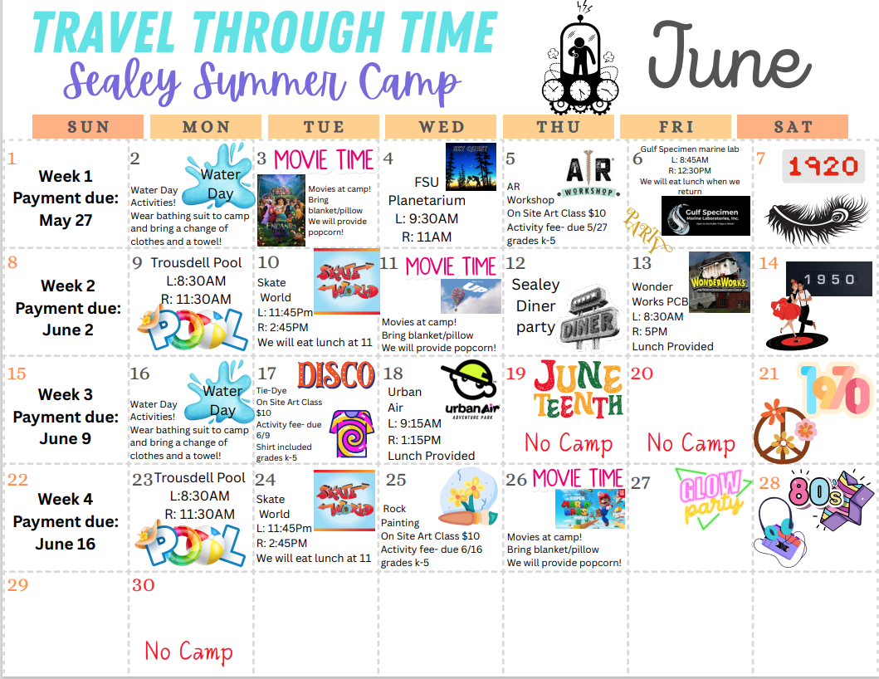

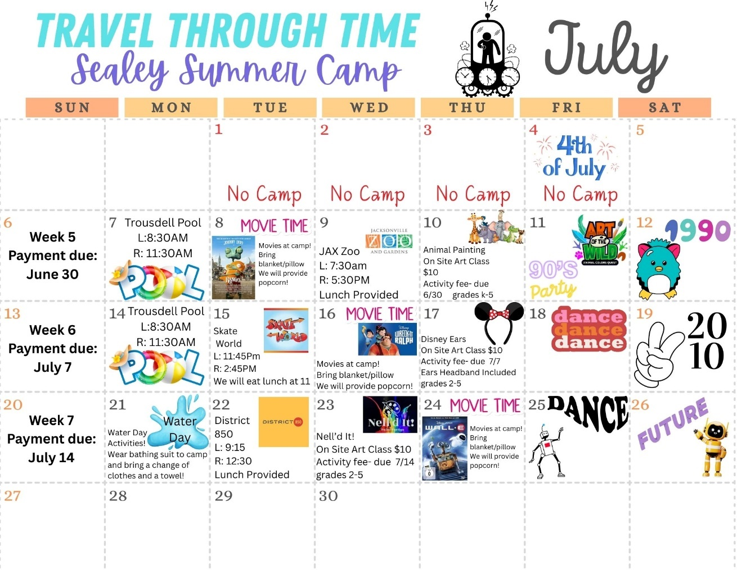

(ACTIVITIES AND FIELD TRIPS ARE SUBJECT TO CHANGE)

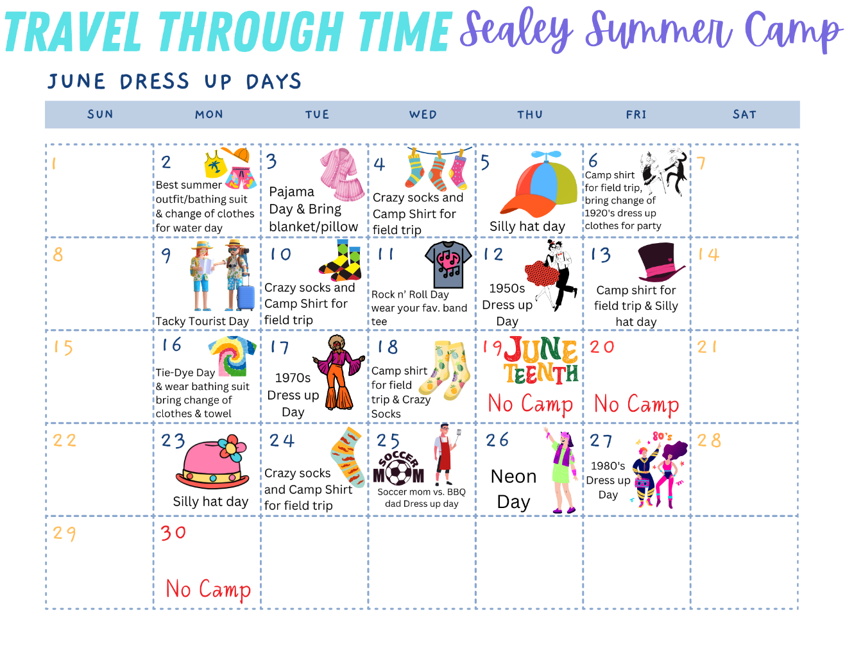

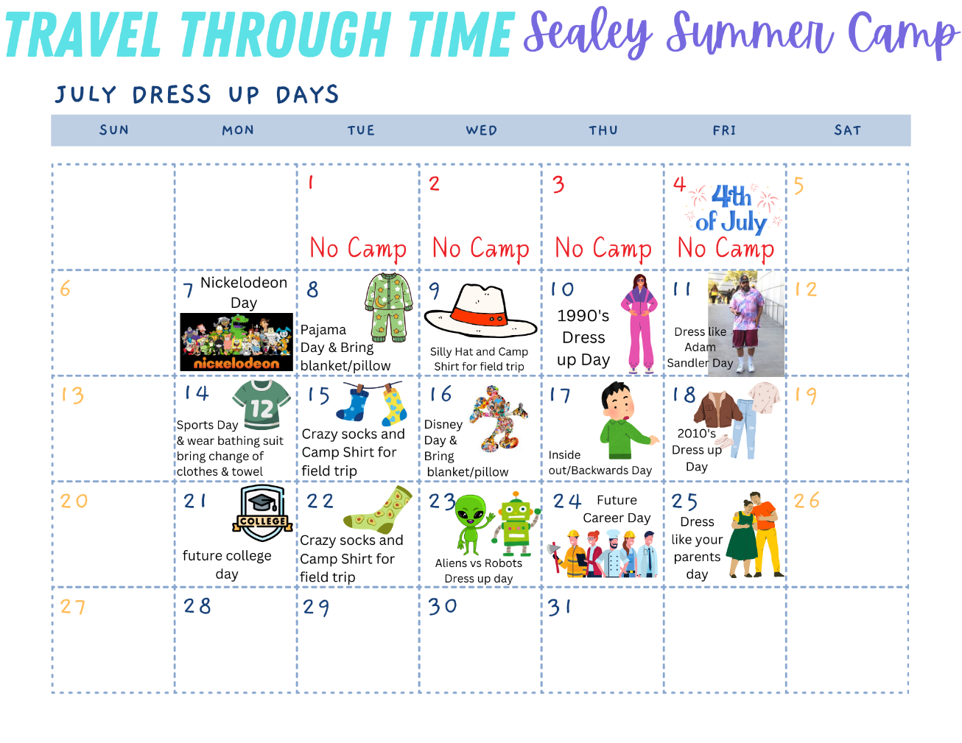

Registration Form

CHILD’S NAME:

BIRTH DATE: / / CHILD’S AGE:­­­­

25-26 ENTERING GRADE: SHIRT SIZE (circle one): child S child M child L adult S adult M adult L

PARENT/ GUARDIAN NAME:

ADDRESS: ZIP CODE:

EMPLOYER: E-MAIL ADDRESS:

WORK PHONE: ( ) - CELL PHONE: ( ) -

PARENT/ GUARDIAN NAME:

ADDRESS: ZIP CODE:

EMPLOYER: E-MAIL ADDRESS:

WORK PHONE: ( ) - CELL PHONE: ( ) -

Is either parent working as an LCS employee over the 2025 summer? Yes No

Any custody issues we should be aware of? Yes No

If yes, please explain:­­­­­­­­­­­­­

The following individuals are allowed to pick up this child and may be contacted in case of an emergency:

EMERGENCY CONTACTS DAY PHONE RELATION TO CHILD

­­­ _____________________________

______________________________

______________________________

List any medications, allergies or limitations requiring special attention:

|  |  |
| --- | --- |
| My child will attend camp the following weeks: | |
| Week 1: June 2 - June 6 | (No Camp) June 30 – July 4 |
| Week 2: June 9 - June 13 | Week 5: July 7 - July 11 |
| Week 3: June 16- June 18 (No Camp June 19-20) | Week 6: July 14 - July 18 |
| Week 4: June 23- June 27 | Week 7: July 21 – July 25 |

***I have read and fully understand the policies outlined in the Policy Statement. I understand the policies and procedures in place are to ensure my child’s safety within the program. I confirm all of the above information is true. I am aware that if my child fails to meet criteria, it may result in removal from the program, in which no refund will be granted.***

PARENT SIGNATURE: DATE: / /

**CHILD’S NAME(S)**:

**TRANSPORTATION**

For field trips provided during summer camp hours, students will be transported by bus. The buses are provided by Tomahawk transportation, and Astro Charter Services.

My child has permission to be transported by bus for camp field trips?

Yes No

**MOVIES**

Due to most children’s animated movies being rated PG, we need your consent to show these movies to your child. Movies are prescreened for approval.

My child has permission to watch a G or PG rated family movie during Summer Camp?

Yes No

**PHOTOGRAPHY**

My child may be photographed to be posted on Class Dojo and in the weekly newsletter for Summer Camp.

Yes No

**INTERNET**

My child has permission to use school devices while at camp. This includes, iPad and PlayStation.

Yes No

**SWIMMING/WATER ACTIVITIES**

My child has permission to participate in water activities with the Sealey Summer Camp program. We will be swimming at the Trousdell Aquatics Center and having water day activities at school.

Yes No

Please indicate your child’s level of swimming ability:

Non-swimmer Some swimming skills Good *swimmer*

***SUNSCREEN***

We provide sunscreen, however, if your child needs a specific type of sunscreen, please provide it with the child’s name printed on the front of the bottle.

I permit the Sealey Summer Camp Staff to apply sunscreen to my child, when they feel it is needed.

Yes No

***I have read and fully understand the statements on this page. I acknowledge and allow the listed permission, as answered above, for my child.***

*PARENT SIGNATURE: DATE: / /*