Point | line | plane | collinear points | coplanar points
Line segment | endpoints | ray | opposite ray | intersecting
Pace the descriptions in the correct column.
Vocabulary Matching – Determine which vocabulary word matches with each description. The words will fit with more than one description.
Points on the same line | Points on the same plane | Points on either end of a line segment | 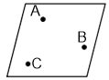
2 dimensions | I dimension | no dimension | Two end points and all the points in between | Ray CA and ray CB when Point C lies on line AB | Formed when two planes meet | $$\overset{↔}{AB}$$
Undefined term | Named with 3 non collinear points | Named with small cursive letter | ABC | An endpoint and all the points that lie on one side of that endpoint | 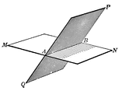 | Formed when three points are connected on a straight line
Undefined term | Undefined term | Defined using Undefined terms | Defined using Undefined terms | $$\overline{AB}$$ | $$\overset{→}{AB}$$ | Formed where a line meets a plane
 | Formed when two lines meet | 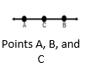 | 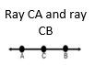 | Formed when two points are connected | 