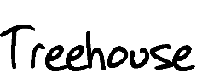

**A.** I’m thinking a castle.

1. I’m thinking a modern penthouse.
2. I’m thinking rustic cabin.
3. I think our first step is to decide what this treehouse will look like, and then we can draw up the plans.
4. But we all want something different.
5. How should we decide whose idea is best?
6. Well, I’m the oldest, so maybe I should decide.
7. My dad is an architect, so maybe I should decide.
8. How about rock, paper, scissors?
9. Okay. *(They play rock, paper, scissors until B wins.)*
10. Yes! I win! Our treehouse will look like a modern penthouse.
11. I don’t even know what that means.
12. Yeah. What is a modern penthouse?
13. It’s a fancy apartment on the top floor with big windows and uncomfortable furniture.
14. How do we build that in a tree?
15. Good point. And I don’t like uncomfortable furniture.
16. Trust me, it’ll be great. I’ll have my dad draw up the plans.
17. It seems kind of complicated.
18. So is a castle, now that I think about it.
19. So what do we do?
20. Maybe we should just climb the tree and sit on the branches.
21. Good idea.
22. Let’s go.

**CURTAIN**

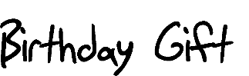

1. Are you going to Sam’s birthday party this weekend?
2. I wasn’t invited.
3. Me neither.
4. Oh, I’m sorry. I thought you were.
5. It’s okay. I don’t know Sam very well anyway.
6. Me neither.
7. Well, I need to think of a good birthday present. Do you have any ideas?
8. What does Sam like?
9. Music.
10. How about a zither or a trombone?

A. I don’t know what a zither is, and I’m pretty sure Sam doesn’t play the trombone.

C. What else does Sam like?

A. Animals.

C How about a Komodo Dragon or a goose?

A. No offense, but I don’t think either of those would make good pets.

C. Picky, picky.

B. There must be something else that Sam likes.

1. Sports.
2. I’ve got the perfect idea. A sailboat.
3. Or a racecar.
4. Not those sports.
5. Listen, we were just trying to help.

A. Thanks, but I think I’ll choose the gift myself.

**CURTAIN**

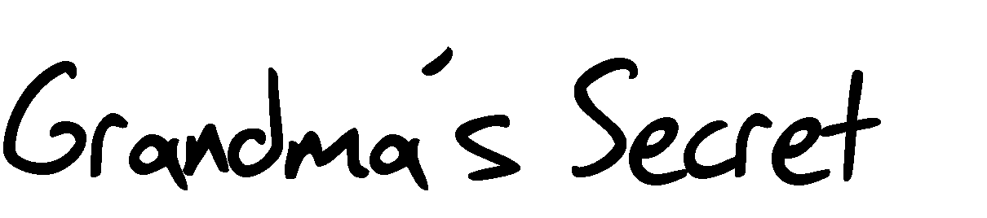

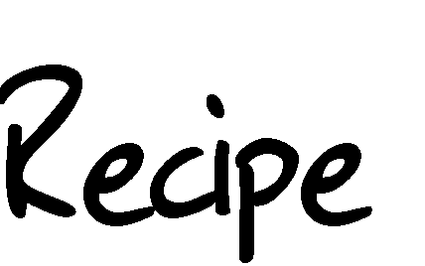

1. Here’s the sugar.
2. And the butter.
3. And the eggs.
4. And the vanilla.
5. And the cinnamon.
6. And the flour.
7. Okay. We’ve got all the ingredients. Let’s get baking.
8. What do we do first?

A. *(Turning recipe card over, looking at both sides, searching.)* I don’t know.

C. Well, what does the recipe say?

A. It just lists the ingredients. No amounts or directions.

B That can’t be right. Give me that. *(Takes the recipe card.)* You’re right.

C. How can we make Grandma’s famous cinnamon twists if we don’t know the recipe?

1. We can’t.
2. Someone else must have the recipe. Maybe Aunt Tilly or Uncle Joe?

A. No. Grandma didn’t share it with anyone because she wanted to keep it a secret.

C. Well a lot of good that does us now.

1. This is terrible. Does this mean we’ll never have cinnamon twists again?
2. They are the taste of childhood.
3. Every holiday. So buttery, sweet, cinnamony.
4. Cinnamony is not a word.
5. What are we gonna do? Should we try to figure it out on our own?
6. Sure. What have we got to lose?

A. Let’s get baking!

**CURTAIN**

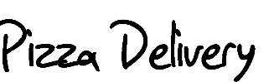

*(Doorbell rings)*

1. Finally! I’m starving.
2. Me too!

*(B and C open the door)*

A. Pizza delivery!

B. Thanks! How much do we owe you?

A. It’s twenty dollars, plus tip.

C. Okay, let me get that. *(gathers money)*

1. It’s a cold night out here.
2. It sure is. That warm pizza will be really good.
3. Warm pizza *is* really good.
4. And we are starving, so thanks again for delivering.
5. Is a five-dollar tip okay?

A. Sure! Anything is appreciated.

C. Okay, here you go. *(Gives money to the delivery person and takes pizza box)*

A. Thanks. *(starts to leave)*

C. Wait! This box is really light.

1. Oh, that happens.
2. *(opening box)* Hey! Wait a minute! There’s only half a pizza.
3. Oh, that happens too.
4. What do you mean?
5. I was really cold and really hungry, so I ate some of your pizza.

(B & C. Uh…)

A. Have a nice night. *(exits)*

**CURTAIN**

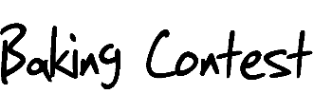

1. Tell us a little about what you’ve baked for us today.
2. Well, it’s a chocolate ganache cake with cherry topping and espresso drizzle.
3. It looks so rich and delicious.
4. Thank you. It’s my signature cake. I love baking this for special occasions.
5. This is certainly a special occasion. If you win today’s competition, you’ll take home ten thousand dollars.
6. That would be amazing!

A. And now you, tell us what you’ve baked for us today.

C. Well, it’s dirt, water, and rocks.

A. I’m sorry, I thought you said, dirt, water, and rocks.

C. I did.

A. But this is a baking competition.

C. I know. I’ve baked a genuine mud pie and decorated it with delicate, round, pebbles.

A. Um… there seems to be a misunderstanding. This is “The Great Baking Competition.”

C. I know. The rules say to bake your specialty. This is my specialty.

A. But it’s not edible.

C. The rules don’t say it has to be edible.

1. I think that’s a given.
2. The rules just say, “use your creativity to bake your specialty and present it in a pleasing way.”

A. You’ve certainly done that.

C. Thank you.

1. Given this clarification, I’m not sure how we will choose a winner.
2. What do you mean? (She/He/They) baked dirt!

A. And it’s lovely.

C. Thank you.

B. I baked this gorgeous, edible, delicious cake.

1. I’m sure it’s wonderful, but now I have to judge on different criteria. Presentation and creativity are just as important as taste.
2. Oh come on!

A. So, with that in mind… all those in favor of the chocolate ganache raise your hands. *(invite the audience to participate)* And all those in favor of the mud pie raise our hands. And the winner is… *(announce the winner)*

*\*You can either choose to end the scene with a winner or not.*

**CURTAIN**



A. What are you doing with our toys? *(Insert whatever specific toy you choose.)*

C. I’m just packing them up.

1. Why?
2. Because you don’t play with them anymore.

A. Well, I know, but…

C. You’re too old for these things anyway.

B. We’re not that old.

A. What are you going to do with them?

C. I thought I’d donate them.

A. Donate them?

C. Yes. Give them to someone who will appreciate them.

A. We appreciate them!

C. But they are just gathering dust in your room.

A. That doesn’t mean you can just give them away.

C. Listen, these were fun when you were little kids. You’re older now and I’m tired of all the junk lying around this house.

1. These are not junk!
2. But there is so much clutter! It’s time to let go of some things.
3. Okay. What are *you* going to let go of?
4. We’re not talking about me. We’re talking about you.

B. I know, and I will choose some things to let go of, but not this.

A. And not this.

C. Okay. We can bargain. What are you willing to part with?

A. How about that freaky stuffed clown?

C. No, not Clownie. Grandma made that for you.

A. Okay. How about the blocks?

C. Not the blocks. Those are handmade by your uncle.

1. What about the giant book of fairytales?
2. Never! That was mine when I was a kid.

A. Oh, I see. You get to hold on to special things because you’re a grown-up, but we can’t because we’re kids.

*(Beat)*

C. Fair enough. Keep the toys.

**CURTAIN**

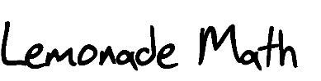

1. Hurry up!
2. Stop bossing us around.

A. Listen here! I *am* your boss. And as the oldest sibling, I have much more experience with lemonade stands than you.

C. How much money are we gonna make?

1. Well it depends on how we run our business.
2. What do you mean? I thought we were just gonna sell some lemonade and people would give us money.

A. Selling lemonade requires strategy. First of all, how much have we invested?

C. What does that mean?

1. Well, how much did the lemonade cost us?
2. Nothing. Mom bought it.

A. Well, that’s true, but the container of lemonade mix was five dollars. So she invested in our company. In theory, we should pay her back.

C. I guess you’re right.

1. So, after we pay her back the five dollars, we can keep whatever money we make after that.
2. How many cups of lemonade will we have to sell?

A. Good question.

C. I think a lot of people will want lemonade on this nice sunny day.

B. We can probably sell a thousand cups of lemonade.

A. That’s ridiculous, but we can at least sell twenty. So, if each cup is 50 cents, how much will we make?

B and C. Uh…

A. Twenty cups of lemonade at 50 cents each is ten dollars.

C. So we make ten dollars?

1. No. Remember, we have to pay Mom back the five dollars she invested, so ten dollars minus five dollars equals five dollars.
2. That’s not very much.
3. Especially if we have to share it between the three of us.
4. Or, we could sell each cup for one dollar and then we’d make…?
5. A thousand dollars?

A. No, we’d make $15.00. Twenty cups x $1.00 each equals $20.00. $20.00 minus the

$5.00 we owe Mom gives us $15.00.

C. That sounds better than splitting $5.00.

1. I wonder what we should do with our money.
2. That’s easy. Candy.
3. Yeah, candy!
4. Life is more than candy.
5. Says you.

A. Well, with a profit of $15.00, we will each get $5.00.

C. We’re gonna be rich!

1. Uh oh! Look up there!
2. Clouds!

A. It looks like rain!

C. Nobody is gonna buy lemonade in the rain!

1. Quick! Grab everything and run inside!
2. Okay! We can always sell hot chocolate!

**CURTAIN**

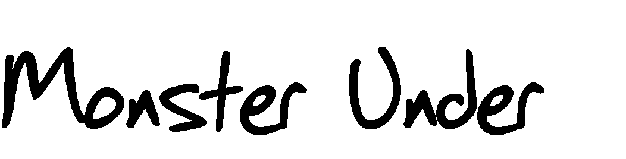

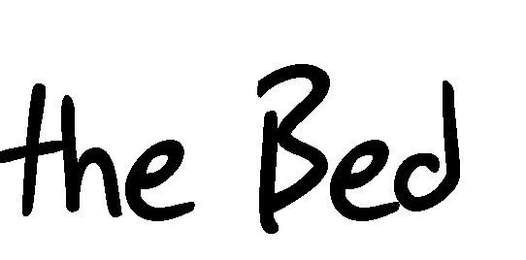

1. Grr…
2. Did you hear that?
3. Hear what?
4. Grr….
5. That!
6. Yes. What is it?

B. I don’t know, but it’s coming from under the bed.

A. Grr…

C. Do you have monsters here at your house?

1. Don’t be ridiculous.
2. I’m not being ridiculous. It sounds like a monster under your bed.
3. Well, there’s only one way to find out.
4. I’m not looking.
5. We have to. It’s the only way to find out what’s making that sound.
6. I told you. It’s a monster. And if we look under your bed it will kill us.
7. I don’t believe in monsters. It’s probably a toy or something.
8. Fine. You look.

*(B slowly peeks under the bed and then jumps back up when A growls again)*

1. Grr…
2. Ahhh!
3. What is it?
4. A monster.
5. I told you!

B. What do we do?

C. Well, we either let it kill us, or we kill it.

1. Please don’t kill me! *(B and C look at each other with surprise.)*
2. What did you say?

A. Please don’t kill me! I’m not a bad monster. I’m just hungry.

C. You’ve got to be kidding me!

B. How did you get under my bed?

A. I’ve always lived here. You just haven’t noticed me.

C. See! You *do* have monsters at your house.

A. You have monsters at your house too.

C. I don’t think so.

1. Sure you do. You just haven’t seen them.
2. Okay. So, what do you want?

A. Like I said, I’m just really hungry.

C. Please don’t eat us!

A. I don’t eat people.

C. What a relief!

1. Can I just have a sandwich or something?
2. Sure. How about a peanut butter and jelly?
3. I’m allergic to nuts.
4. Okay. How about a bagel with cream cheese?

A. Perfect!

C. You go get it! *(nervous)*

B. I’m not gonna get it. You get it? *(nervous)*

A. Fine, I’ll go get it. *(Monster climbs out and goes to get sandwich)*

**CURTAIN**

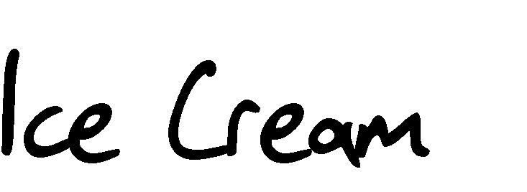

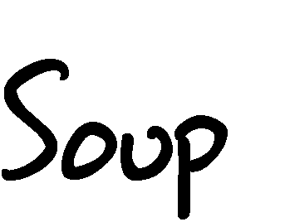

1. Vanilla is the best!
2. No way! Chocolate is the best!
3. Are you two crazy? Cookie dough all the way!
4. Maybe I’ll shake it up today and get mint chip?
5. Oooh. That’s good. I think I’ll do something different too. Maybe strawberry swirl.
6. Not me. I’m sticking with cookie dough.
7. It’s all good. You can’t go wrong with ice cream on a summer day.
8. Except that one time.
9. What one time?

A. Oh yeah. I remember. That was a tragic day.

C. Why? What happened?

1. Well, we went to the ice cream shop and ordered our usual.
2. But they ran out of cones, so they gave us our ice cream in dishes.

A. Which was fine with us because they gave us triple scoops.

C. Triple scoops? That doesn’t sound tragic.

B. Just wait. Right when we walked out of the ice cream shop we saw this dog.

1. He was so cute, but he looked like he was lost, so we had to help him.
2. We put our ice cream down on the bench and managed to catch the dog.
3. He didn’t have a collar on.
4. Right. So we knew he was probably a stray. Poor guy.
5. I’ve always wanted a dog, so I thought, this is my chance! Maybe I can keep him.
6. We looked up and down the street to see if his owner was around. We even asked in a couple of the shops, but nothing.

A. I was so excited! I named him Scoop because we found him by the ice cream shop.

C. Cute.

1. Then it happened.
2. Oh no! Did the dog get hit by a car?

A. No. Worse.

C. How can it be worse than that?

A. The owner came back for him.

C. But that’s good.

A. No! It means I didn’t get to keep him.

C. It all turned out for the best.

B. Except for our ice cream.

A. It melted. Ice cream soup.

C. Was it good?

1. Not bad.
2. Not bad at all.

**CURTAIN**

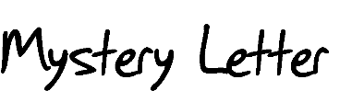

1. I am so bored.
2. Me too.

A. Nothing fun ever happens around here.

C. *(entering)* Hey, this letter just arrived and has all of our names on it.

1. Who’s it from?
2. I don’t know. It doesn’t say.

A. Well open it up.

C. Okay.

1. Read it to us.
2. “Follow these clues to get rid of the blues.”
3. That’s strange.
4. Is it a mystery or something?
5. I don’t know.

A. Keep reading.

C. Okay. “Step one. Look by the door and you will see more.”

B. More what?

A. Hey! There’s a letter taped to the door. What should I do with it?

C. “Step two. Open the letter and things will get better.”

1. This person sure likes rhyming.
2. What does the second letter say?
3. It says, “Have fun together in all kinds of weather.”
4. What does that mean?

A. I don’t know.

C. “Step three. It’s sunny today so go out and play.”

B. Does that mean we should go outside?

1. What would we do out there?
2. I don’t know.
3. Maybe we could make up a mystery.
4. That’s a fun idea.
5. Maybe it could be about a group of kids who find a treasure map.
6. Or maybe they discover a letter written by their great great great grandfather.
7. Or maybe it’s a letter that tells them about some historical event.
8. You know what?
9. What?

B. I’m not bored anymore.

A. Me neither.

C. Let’s go!

**CURTAIN**